COVID and Appalachians Update
Background
In 2020, the UACC Research Committee tracked COVID-19 cases and deaths in Cincinnati neighborhoods starting June 1 and ending at the peak of the third wave in December. We found that the largest concentrations of cases were in the West Side neighborhoods of Westwood, West Price Hill and East Price Hill. Thousands of Appalachians, Blacks and Hispanics live in this area. We successfully advocated that the number of test sites of the west side be increased.
During the first several months of 2021, cases and deaths declined in Cincinnati and we began to focus on administration of vaccines. In June, we collaborated with the Center for Closing the Health Gap to ask Price Hill churches to serve as vaccination sites. Most said no or did not return our calls. The churches that did open their doors were disappointed by how few people responded.
Appalachians and Vaccination
In Ohio and Cincinnati, the number of vaccinations increased steadily from January through May. Ohio achieved a vaccination rate of 46.94% among adults and youth and Cincinnati fully vaccinated 42,957 people over 12. In Ohio, vaccination rates in most Appalachians counties (and a few other mostly rural counties) ranged from 14.82% in Holmes County to 45.23% in Clermont but most were closer to a 33% rate. In the nation, ten of the states with the lowest vaccination rates had Appalachian counties.
The Coming Fourth Wave
In Cincinnati, the pattern is similar. As the Delta variant of the coronavirus surges in states with low vaccination rates, Cincinnati’s Appalachian, Black, and Hispanic areas tend to have the lowest vaccination rates. Although Blacks make up about 44% of the City’s population they constitute hardly a third of the people vaccinated. In the three western riverside neighborhoods only 155 people have been vaccinated. In East Price Hill only 595 out of 18,000 people. In mostly Black Avondale, only 478 compared to 1,423 in Hyde Park. In Carthage, a center of Hispanic settlement, only 49 people are fully vaccinated. Clearly Cincinnati minority neighborhoods will continue to be very much at risk as the Delta variant surges in Cincinnati. The city, Hamilton County, and the public health community must increase their efforts to get our people vaccinated. UACC will do its part by keeping its network informed about the facts of COVID and what it means for this community. We welcome our readers’ ideas about the situation we are in and what needs to be done.
The graphs below show the emergence of the fourth wave in Cincinnati. The transmission rate is 174.71 cases per 100,000 in Cincinnati as of August 13. As expected, the transmission is highest in areas like Sedamsville and East Price Hill with lowest vaccination rates. Indoor mask wearing, social distancing and watching for symptoms is recommended for Hamilton County and all surrounding counties because of the high transmission rates here.
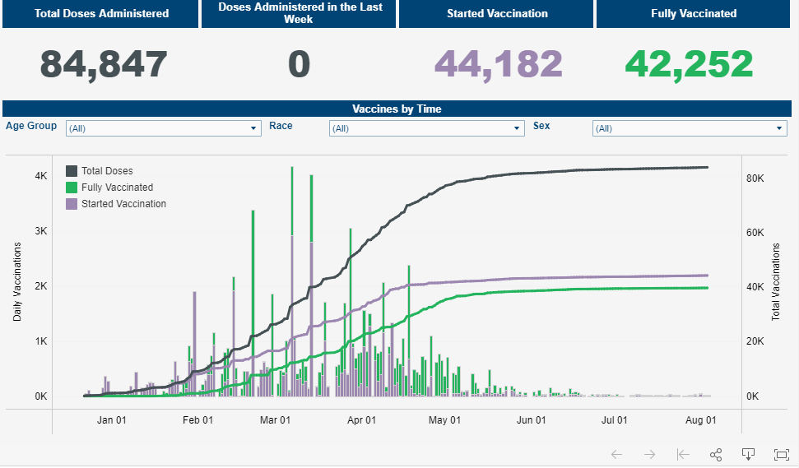
Source: Cincinnati Health Department, August, 2021

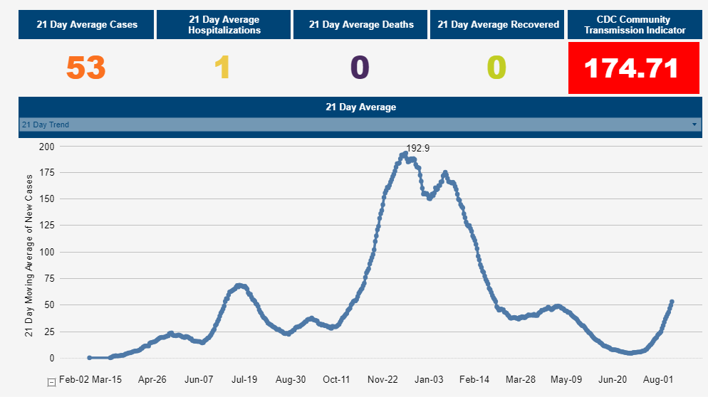
Source: Cincinnati Health Department, August, 2021

Michael Maloney
meamon@aol.com
August 13, 2021

