Entering the Third Wave: The Geography and Demographics of the Coronavirus in Cincinnati

December 14, 2020

Introduction
The Cincinnati Health Department has been tracking the Coronavirus by neighborhood, age, gender, and race since March 23. An interactive map and charts are updated each day (https://www.cincinnati-oh.gov/health/covid-19/. We felt it was important to plot the data at discrete times and look for trends and anomalies. We have also been monitoring the availability of testing sites in different sections of the city. (If there is no testing, it affects the data.) Since November, we have added a section which shows the evolution of the virus as it goes into its third surge and makes suggestions for public response.

Demography of Covid Deaths and Confirmed Cases

Race and Ethnicity
Table 1 shows the distribution of deaths and confirmed cases at approximately monthly intervals from June 1 to December 14. During that period, black deaths increased from 24 to 65 (170.%). White deaths increased from 20 to 57 (185.0%). Hispanic deaths increased from 0 to 1. Note that race and ethnicity are not always recorded. As of December 14, the number of unknown deaths had increased to 18 (260.0%).
The picture in Table 1 is similar for confirmed cases of Covid 19. Since June 1, the number of black cases had increased from 368 to 4,904 (1232.6%) and the number of white cases increased from 324 to 5,716 (1664.2%). The number of Hispanic cases had increased from 195 to 356 (82.6%) but the data shows no new cases between November 14 and December 14. This is an anomaly that needs explanation.
Table 1: Deaths and Confirmed Cases by Race and Ethnicity
 | Deaths |  |  |  |  | Cases
Race | 1-Jun | 14-Nov | 14-Dec | %Inc  Since Nov. 14 | %Inc  Since June 1 | 1-Jun | 14-Nov | 14-Dec | %Inc  Since Nov. 14 | %Inc  Since June 1
Black | 24 | 59 | 65 | 10.2% | 170.8% | 368 | 3,233 | 4,904 | 51.7% | 1232.6%
Hispanic | 0 | 1 | 1 | 0.0% | NA | 195 | 356 | 356 | 0.0% | 82.6%
White | 20 | 46 | 57 | 23.9% | 185.0% | 324 | 3,636 | 5,716 | 57.2% | 1664.2%
Other | 3 | 5 | 7 | 40.0% | 133.3% | 77 | 445 | 747 | 67.9% | 870.1%
Unknown | 5 | 13 | 18 | 38.5% | 260.0% | 165 | 1,562 | 3,178 | 103.5% | 1826.1%
Total | 52 | 124 | 148 | 19.35% | 184.62% | 1,129 | 9,232 | 14,901 | 61.41% | 1219.84%
Source: Cincinnati Health Department, June 1, November 14, December 14
Table 1 shows that, in December, 32.9% of confirmed cases were black compared to 38.4% which are white. The percentage of race unknown cases grew from 9.6% to 21.3% from June to December and the number of unknown cases grew by about 96.5% (1616 cases) in the past month. There is still a problem with recording the race and ethnicity of Covid cases and it is growing as the epidemic surges

Table 2: Deaths and Confirmed Cases by Population
 | Expected % | Deaths (Actual %) |  |  | Cases (Actual %)
Race |  | 1-Jun | 14-Nov | 14-Dec | 1-Jun | 14-Nov | 14-Dec
Black | 42.7 | 46.2 | 47.6% | 43.9% | 32.6 | 35.0% | 32.9%
Hispanic | 3.7 | 0 | 0.8% | 0.7% | 17.3 | 3.9% | 2.4%
White | 48.2 | 38.5 | 37.1% | 38.5% | 28.7 | 39.4% | 38.4%
Other | 5.4 | 5.8 | 4.0% | 4.7% | 6.8 | 4.8% | 5.0%
Unknown | NA | 9.6 | 10.5% | 12.2% | 14.6 | 16.9% | 21.3%
Source: Cincinnati Health Department June 1, November 14, December 14
Blacks in Cincinnati are more likely to die from the virus than whites but the disparity is not increasing over time. From November 14 to December, the share of cases for both blacks and whites declined slightly but this is likely because the share of “unknown” cases went up about 5 points.

Age
Table 3 shows that the number of deaths as of December 14 is still highest in the older age ranges. There are no recorded deaths for the under 30 population and only 2 in the under 40 population. During the first surge, the numbers of cases and percentages of increase really jumped in the younger population groups. However, in the fall surge dramatic increases have occurred across the age groups, but especially among the 40-80 age range. The largest percent increase as of December 14 was in the 0-9 age group at 78% -- still only 412 cases though, out of 14,873. The 40-49 group jumped by 75%. The virus is not killing our young people but is surging among the 20-60 population. There are now over 4,000 cases in the 20-29 age group. The experts are concerned about possible long term effects of the virus on young people.
Table 3: Age Distribution of Deaths and Confirmed Cases
Age Group | Deaths |  |  |  |  | Cases
 | 1-Jun | 14-Nov | 14-Dec | % Inc (since June) | % Inc (month) | 1-Jun | 14-Nov | 14-Dec | % Inc (since June) | % Inc (month)
0-9 | 0 | 0 | 0 | NA | NA | 22 | 231 | 412 | 1773% | 78%
10-19 | 0 | 0 | 0 | NA | NA | 42 | 1,029 | 1,503 | 3479% | 46%
20-29 | 0 | 0 | 0 | NA | NA | 172 | 2,762 | 4,329 | 2417% | 57%
30-39 | 1 | 2 | 3 | 200% | 50% | 251 | 1,640 | 2,703 | 977% | 65%
40-49 | 1 | 5 | 5 | 400% | 0% | 160 | 981 | 1,712 | 970% | 75%
50-59 | 3 | 9 | 11 | 267% | 22% | 158 | 1,058 | 1,767 | 1018% | 67%
60-69 | 12 | 33 | 35 | 192% | 6% | 134 | 822 | 1,310 | 878% | 59%
70-79 | 5 | 23 | 30 | 500% | 30% | 79 | 387 | 629 | 696% | 63%
80-89 | 16 | 28 | 34 | 113% | 21% | 73 | 205 | 343 | 370% | 67%
90-99 | 11 | 20 | 30 | 173% | 50% | 35 | 94 | 159 | 354% | 69%
100 – | 3 | 4 | 4 | 33% | 0% | 3 | 6 | 6 | 100% | 0%
Total | 52 | 124 | 152 | 192.31% | 22.58% | 1,129 | 9,215 | 14,873 | 1217.36% | 61.40%
Source: Cincinnati Health Department June 1, November 14, December 14

Sex
As of December 14, there have been 6,853 confirmed cases among males and 8,048 among females. The deaths were 73 male and 75 female.
Table 3a: Deaths and Confirmed Cases by Sex
Deaths |  | Cases
Male | Female | Male | Female
73 | 75 | 6,853 | 8,048
Source: Cincinnati Health Department, December 14

Neighborhood Distribution
Table 4 shows the neighborhoods with the highest numbers of cases. These fourteen neighborhoods have large populations but some also have minority populations, significant poverty rates and high numbers of cases per capita. Five are on the west side of the city. As of December 14, these neighborhoods had 60.7% of Cincinnati’s confirmed Covid-19 cases.
Table 4: Hot Spots
Large Number of Cases |  |  |  | Other Neighborhoods with over 200 Cases as of December 14
 | 1-Jun | 14-Nov | 14-Dec |  | 1-Jun | 14-Nov | 14-Dec
Westwood | 209 | 947 | 1505 | Walnut Hills | 20 | 147 | 274
CUF | 17 | 720 | 936 | Over-the-Rhine | 7 | 174 | 263
West Price Hill | 114 | 557 | 805 | Mt. Auburn | 11 | 143 | 251
College Hill | 45 | 382 | 633 | Corryville | 3 | 177 | 243
Oakley | 29 | 345 | 588 | Hartwell | 42 | 153 | 235
Hyde Park | 20 | 316 | 574 | Clifton | 18 | 139 | 231
East Price Hill | 154 | 379 | 549 | Mt. Lookout | 9 | 117 | 217
Avondale | 47 | 289 | 440 | Northside | 17 | 139 | 215
Madisonville | 18 | 249 | 433 | West End | 13 | 130 | 213
Mt.Airy | 40 | 277 | 417
Mt. Washington | 27 | 212 | 417
Evanston | 19 | 237 | 369
Bond Hill | 29 | 204 | 367
CBD/Riverfront | 9 | 240 | 365
Pleasant Ridge | 60 | 186 | 329
Roselawn | 20 | 213 | 304
Source: Cincinnati Health Department June 1, November 14, December 14
The nine neighborhoods in the right hand column have confirmed cases in the 200-300 range.
Table 5: Neighborhoods Sorted Alphabetically with percent of case increases since June 1 and from November 14-December 15
Neighborhood | 1-Jun | 14-Nov | 14-Dec | %Inc  Since June | %Inc  (Month) | Neighborhood | 1-Jun | 14-Nov | 14-Dec | %Inc  Since June | %Inc  (Month)
Avondale | 47 | 289 | 440 | 836.17% | 52.25% | Mt. Airy | 40 | 277 | 412 | 930.00% | 48.74%
Bond Hill | 29 | 204 | 367 | 1165.52% | 79.90% | Mt. Auburn | 11 | 143 | 251 | 2181.82% | 75.52%
California | 0 | 6 | 9 | NA | 50.00% | Mt. Lookout | 9 | 117 | 217 | 2311.11% | 85.47%
Camp Washington | 2 | 35 | 65 | 3150.00% | 85.71% | Mt. Washington | 27 | 212 | 417 | 1444.44% | 96.70%
Carthage | 11 | 60 | 89 | 709.09% | 48.33% | N. Avondale – Paddock Hills | 7 | 87 | 139 | 1885.71% | 59.77%
CBD-Riverfront | 9 | 240 | 365 | 3955.56% | 52.08% | N. Fairmount | 5 | 34 | 50 | 900.00% | 47.06%
Clifton | 18 | 139 | 231 | 1183.33% | 66.19% | Northside | 17 | 139 | 215 | 1164.71% | 54.68%
Clifton/University Heights—Fairview (CUF) | 9 | 720 | 936 | 10300.00% | 30.00% | Oakley | 29 | 345 | 588 | 1927.59% | 70.43%
College Hill | 45 | 382 | 633 | 1306.67% | 65.71% | Over-the-Rhine | 7 | 174 | 263 | 3657.14% | 51.15%
Columbia-Tusculum | 1 | 30 | 57 | 5600.00% | 90.00% | Pendleton | 0 | 41 | 57 | NA | 39.02%
Corryville | 3 | 177 | 243 | 8000.00% | 37.29% | Pleasant Ridge | 60 | 186 | 329 | 448.33% | 76.88%
E. Walnut Hills | 8 | 85 | 157 | 1862.50% | 84.71% | Queensgate | 2 | 6 | 10 | 400.00% | 66.67%
East End | 0 | 21 | 48 | NA | 128.57% | Riverside | 3 | 45 | 63 | 2000.00% | 40.00%
East Price Hill | 154 | 379 | 549 | 256.49% | 44.85% | Roselawn | 20 | 213 | 304 | 1420.00% | 42.72%
East Westwood | 21 | 65 | 91 | 333.33% | 40.00% | S. Cumminsville | 3 | 26 | 34 | 1033.33% | 30.77%
English Woods | 1 | 8 | 10 | 900.00% | 25.00% | S. Fairmount | 3 | 54 | 72 | 2300.00% | 33.33%
Evanston | 19 | 237 | 369 | 1842.11% | 55.70% | Sayler Park | 1 | 77 | 133 | 13200.00% | 72.73%
Hartwell | 42 | 153 | 235 | 459.52% | 53.59% | Sedamsville | 2 | 12 | 15 | 650.00% | 25.00%
Hyde Park | 20 | 316 | 574 | 2770.00% | 81.65% | Spring Grove Village | 5 | 47 | 73 | 1360.00% | 55.32%
Kennedy Heights | 20 | 116 | 184 | 820.00% | 58.62% | Villages at Roll Hill | 3 | 39 | 58 | 1833.33% | 48.72%
Linwood | 1 | 9 | 23 | 2200.00% | 155.56% | Walnut Hills | 20 | 147 | 274 | 1270.00% | 86.39%
Lower Price Hill | 8 | 19 | 30 | 275.00% | 57.89% | West End | 13 | 130 | 213 | 1538.46% | 63.85%
Madisonville | 18 | 249 | 433 | 2305.56% | 73.90% | West Price Hill | 114 | 557 | 805 | 606.14% | 44.52%
Millvale | 2 | 30 | 50 | 2400.00% | 66.67% | Westwood | 209 | 947 | 1505 | 620.10% | 58.92%
Mt. Adams | 0 | 41 | 77 | NA | 87.80% | Winton Hills | 12 | 78 | 127 | 958.33% | 62.82%
Table 5 shows the trends in the entire list of Cincinnati neighborhoods. The author will provide periodic updates.

Conclusions
The data presented in this report need to be considered in the location of testing sites and in the allocation of outreach, contact tracing, and education resources. The neighborhoods listed in Table 4 should be top priority. Table A-1 (Appendix) lists the neighborhoods sorted by the highest monthly percent increase. They include Mt. Washington and Hyde Park which already have over 400 cases and some with low case numbers but with monthly increases of over 80%. Something is going on there and this needs attention by neighborhood leaders and public officials.

The Third Wave: Description and Advice
The city of Cincinnati data on Covid-19 New Cases continued its sharp upward climb during the period Nov 14- Dec 14. There was a one-week flattening during the Thanksgiving holiday week that could possibly be attributed to lack of data -- fewer testing sites, less testing demand, etc. The curve resumed its incline the following week, reflecting Thanksgiving-week infections.
However, the week of Dec 14 has begun with two days of uncharacteristically low numbers without apparent explanation. The MSD wastewater numbers are slightly off their peak on Nov 22, suggesting the possibility of a real post-Thanksgiving leveling. This trend could easily be reversed, so we will have to wait and see.
Without further data, this two-day dip should be insufficient to sway us from the most acute vigilance and concern. If the post-December-holiday numbers continue the spike, we could face an extremely dangerous situation just as the vaccines begin providing incremental safety. Intuitively, holiday travel and mixing of households allow the virus to cross social boundaries that we have worked for months to maintain. We are at a point where large family gatherings may need only to be postponed a few months. It is worth the delay to keep our families safe.

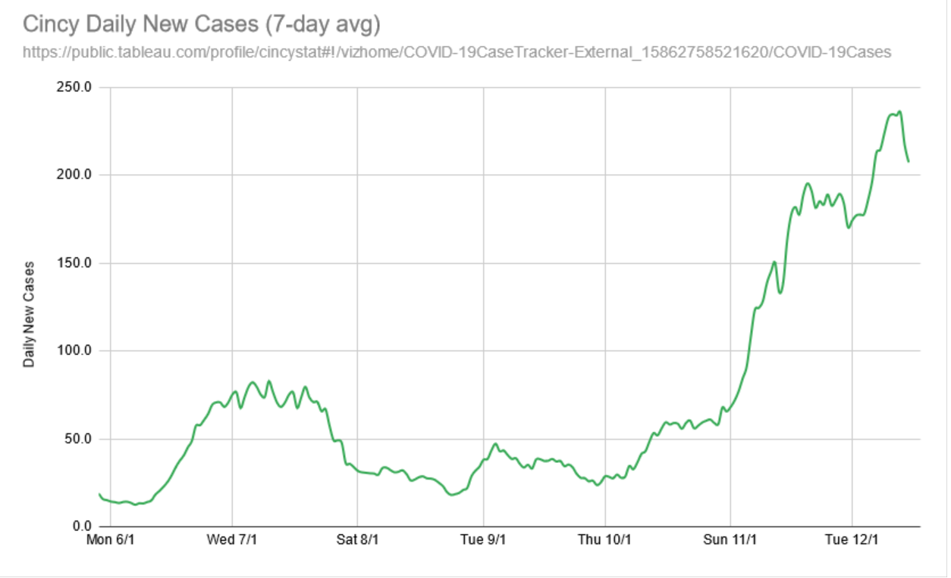

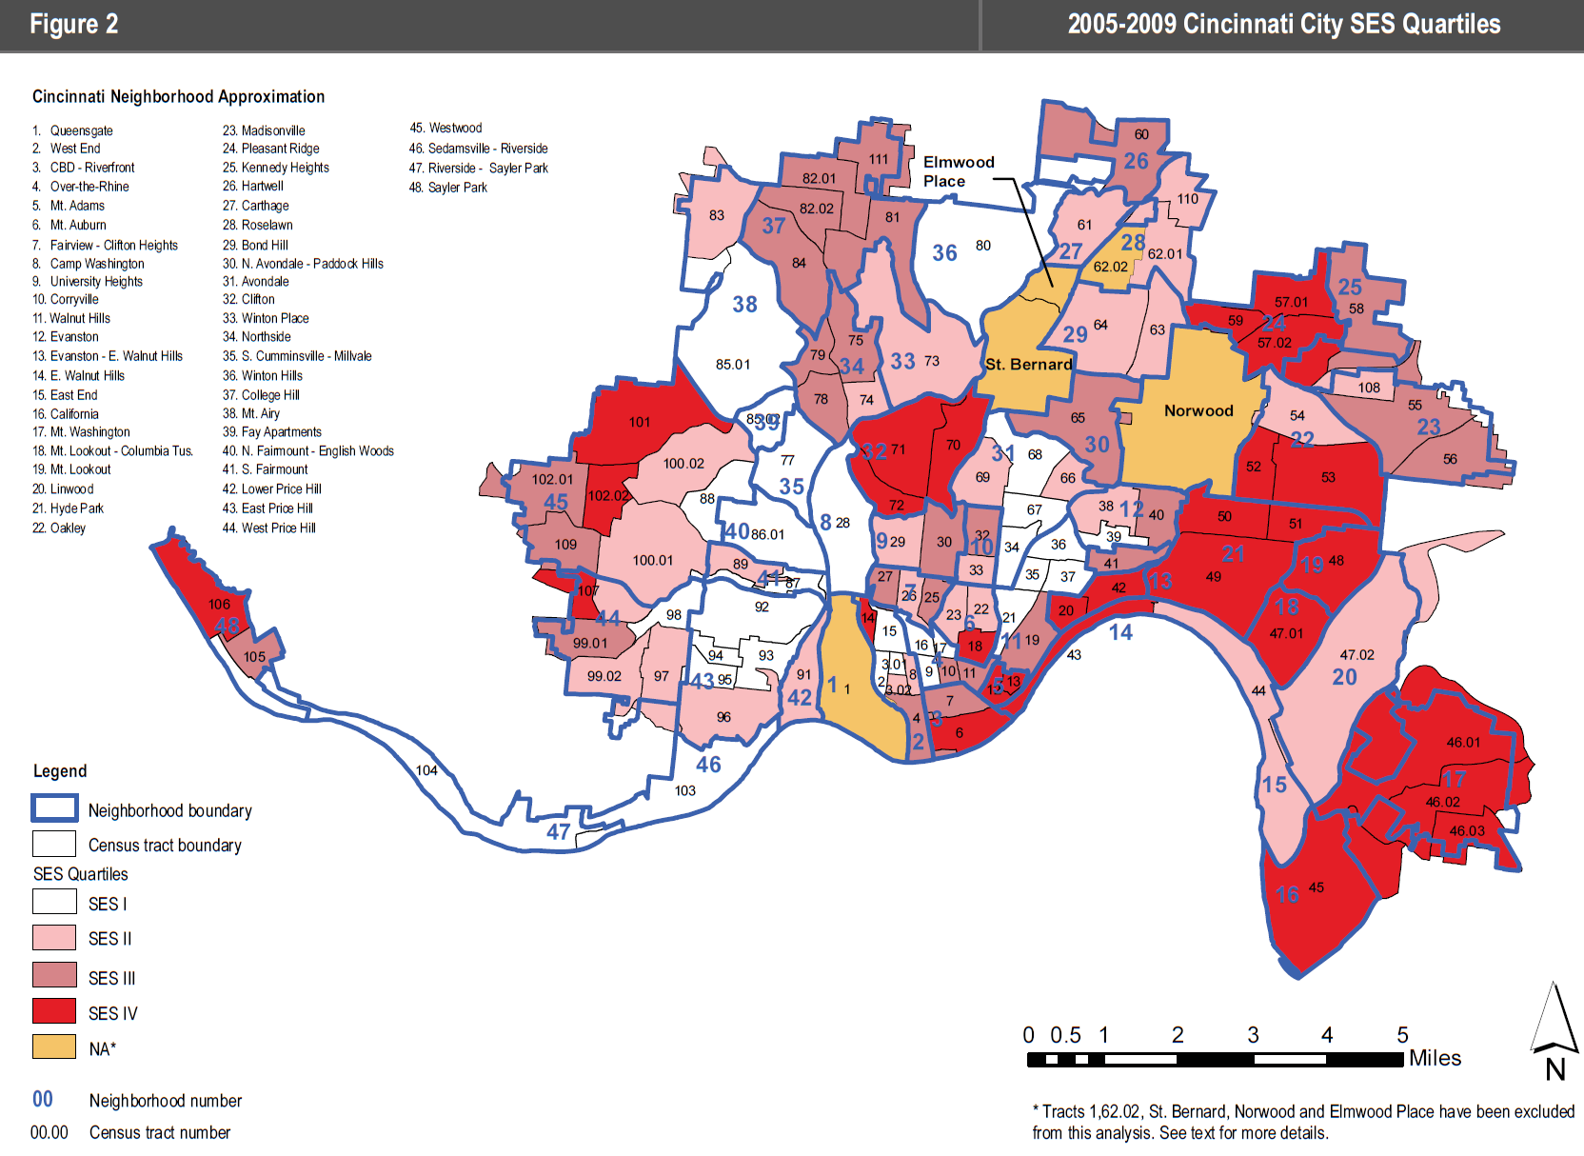
Source: Cincinnati Health Department June 1, July 7, November 14, December 14
Michael Maloney is Convener of the Urban Appalachian Community Coalition, a community organizer and social researcher. His publications include the five editions of the Social Areas of Cincinnati: Analysis of Social Needs (vols. 4-5 with Christopher Auffrey).
John Bealle is an independent scholar and chair of the Urban Appalachian Community Coalition’s Communications Committee.

Appendix
Table A-1: Neighborhoods Sorted by November to December Increase
Neighborhood | 1-Jun | 7-Jul | 13-Aug | 14-Sep | 14-Oct | 14-Nov | 14-Dec | %Inc  Since June | %Inc  (Month)
Linwood | 1 | 2 | 3 | 3 | 6 | 9 | 23 | 2200.00% | 155.56%
East End | 0 | 2 | 6 | 9 | 10 | 21 | 48 | NA | 128.57%
Mt. Washington | 27 | 55 | 86 | 114 | 146 | 212 | 417 | 1444.44% | 96.70%
Columbia-Tusculum | 1 | 2 | 6 | 11 | 20 | 30 | 57 | 5600.00% | 90.00%
Mt. Adams | 0 | 4 | 8 | 12 | 25 | 41 | 77 | NA | 87.80%
Walnut Hills | 20 | 56 | 84 | 95 | 108 | 147 | 274 | 1270.00% | 86.39%
Camp Washington | 2 | 6 | 20 | 22 | 22 | 35 | 65 | 3150.00% | 85.71%
Mt. Lookout | 9 | 14 | 35 | 65 | 88 | 117 | 217 | 2311.11% | 85.47%
E. Walnut Hills | 8 | 18 | 34 | 41 | 57 | 85 | 157 | 1862.50% | 84.71%
Hyde Park | 20 | 35 | 92 | 140 | 205 | 316 | 574 | 2770.00% | 81.65%
Bond Hill | 29 | 93 | 132 | 140 | 158 | 204 | 367 | 1165.52% | 79.90%
Pleasant Ridge | 60 | 84 | 108 | 121 | 143 | 186 | 329 | 448.33% | 76.88%
Mt. Auburn | 11 | 39 | 69 | 85 | 103 | 143 | 251 | 2181.82% | 75.52%
Madisonville | 18 | 56 | 108 | 118 | 159 | 249 | 433 | 2305.56% | 73.90%
Sayler Park | 1 | 9 | 21 | 39 | 55 | 77 | 133 | 13200.00% | 72.73%
Oakley | 29 | 56 | 114 | 159 | 215 | 345 | 588 | 1927.59% | 70.43%
Queensgate | 2 | 2 | 3 | 3 | 4 | 6 | 10 | 400.00% | 66.67%
Millvale | 2 | 11 | 17 | 18 | 20 | 30 | 50 | 2400.00% | 66.67%
Clifton | 18 | 38 | 70 | 81 | 91 | 139 | 231 | 1183.33% | 66.19%
College Hill | 45 | 162 | 229 | 261 | 296 | 382 | 633 | 1306.67% | 65.71%
West End | 13 | 63 | 95 | 106 | 114 | 130 | 213 | 1538.46% | 63.85%
Winton Hills | 12 | 34 | 52 | 56 | 64 | 78 | 127 | 958.33% | 62.82%
N. Avondale – Paddock Hills | 7 | 25 | 51 | 57 | 65 | 87 | 139 | 1885.71% | 59.77%
Westwood | 209 | 451 | 617 | 692 | 757 | 947 | 1505 | 620.10% | 58.92%
Kennedy Heights | 20 | 45 | 69 | 76 | 92 | 116 | 184 | 820.00% | 58.62%
Lower Price Hill | 8 | 16 | 18 | 18 | 18 | 19 | 30 | 275.00% | 57.89%
Evanston | 19 | 61 | 106 | 127 | 181 | 237 | 369 | 1842.11% | 55.70%
Spring Grove Village | 5 | 17 | 25 | 26 | 30 | 47 | 73 | 1360.00% | 55.32%
Northside | 17 | 43 | 70 | 85 | 89 | 139 | 215 | 1164.71% | 54.68%
Hartwell | 42 | 78 | 105 | 108 | 120 | 153 | 235 | 459.52% | 53.59%
Avondale | 47 | 122 | 186 | 220 | 243 | 289 | 440 | 836.17% | 52.25%
CBD-Riverfront | 9 | 38 | 105 | 119 | 166 | 240 | 365 | 3955.56% | 52.08%
Over-the-Rhine | 7 | 50 | 85 | 93 | 111 | 174 | 263 | 3657.14% | 51.15%
California | 0 | 1 | 1 | 2 | 2 | 6 | 9 | NA | 50.00%
Mt. Airy | 40 | 127 | 190 | 206 | 226 | 277 | 412 | 930.00% | 48.74%
Villages at Roll Hill | 3 | 22 | 29 | 32 | 32 | 39 | 58 | 1833.33% | 48.72%
Carthage | 11 | 23 | 29 | 33 | 41 | 60 | 89 | 709.09% | 48.33%
N. Fairmount | 5 | 19 | 24 | 25 | 29 | 34 | 50 | 900.00% | 47.06%
East Price Hill | 154 | 224 | 272 | 293 | 312 | 379 | 549 | 256.49% | 44.85%
West Price Hill | 114 | 198 | 292 | 325 | 384 | 557 | 805 | 606.14% | 44.52%
Roselawn | 20 | 65 | 114 | 125 | 145 | 213 | 304 | 1420.00% | 42.72%
East Westwood | 21 | 40 | 52 | 53 | 56 | 65 | 91 | 333.33% | 40.00%
Riverside | 3 | 5 | 14 | 19 | 23 | 45 | 63 | 2000.00% | 40.00%
Pendleton | 0 | 7 | 17 | 20 | 21 | 41 | 57 | NA | 39.02%
Corryville | 3 | 13 | 31 | 90 | 138 | 177 | 243 | 8000.00% | 37.29%
S. Fairmount | 3 | 32 | 45 | 47 | 48 | 54 | 72 | 2300.00% | 33.33%
S. Cumminsville | 3 | 9 | 12 | 15 | 16 | 26 | 34 | 1033.33% | 30.77%
Clifton/University Heights—Fairview (CUF) | 9 | 45 | 128 | 376 | 583 | 720 | 936 | 10300.00% | 30.00%
Sedamsville | 2 | 3 | 7 | 7 | 8 | 12 | 15 | 650.00% | 25.00%
English Woods | 1 | 1 | 2 | 5 | 7 | 8 | 10 | 900.00% | 25.00%

Table A-2: Neighborhoods Sorted by June to December Increase
Neighborhood | 1-Jun | 7-Jul | 13-Aug | 14-Sep | 14-Oct | 14-Nov | 14-Dec | %Inc  Since June | %Inc  (Month)
East End | 0 | 2 | 6 | 9 | 10 | 21 | 48 | NA | 128.57%
Mt. Adams | 0 | 4 | 8 | 12 | 25 | 41 | 77 | NA | 87.80%
California | 0 | 1 | 1 | 2 | 2 | 6 | 9 | NA | 50.00%
Pendleton | 0 | 7 | 17 | 20 | 21 | 41 | 57 | NA | 39.02%
Sayler Park | 1 | 9 | 21 | 39 | 55 | 77 | 133 | 13200.00% | 72.73%
Clifton/University Heights—Fairview (CUF) | 9 | 45 | 128 | 376 | 583 | 720 | 936 | 10300.00% | 30.00%
Corryville | 3 | 13 | 31 | 90 | 138 | 177 | 243 | 8000.00% | 37.29%
Columbia-Tusculum | 1 | 2 | 6 | 11 | 20 | 30 | 57 | 5600.00% | 90.00%
CBD-Riverfront | 9 | 38 | 105 | 119 | 166 | 240 | 365 | 3955.56% | 52.08%
Over-the-Rhine | 7 | 50 | 85 | 93 | 111 | 174 | 263 | 3657.14% | 51.15%
Camp Washington | 2 | 6 | 20 | 22 | 22 | 35 | 65 | 3150.00% | 85.71%
Hyde Park | 20 | 35 | 92 | 140 | 205 | 316 | 574 | 2770.00% | 81.65%
Millvale | 2 | 11 | 17 | 18 | 20 | 30 | 50 | 2400.00% | 66.67%
Mt. Lookout | 9 | 14 | 35 | 65 | 88 | 117 | 217 | 2311.11% | 85.47%
Madisonville | 18 | 56 | 108 | 118 | 159 | 249 | 433 | 2305.56% | 73.90%
S. Fairmount | 3 | 32 | 45 | 47 | 48 | 54 | 72 | 2300.00% | 33.33%
Linwood | 1 | 2 | 3 | 3 | 6 | 9 | 23 | 2200.00% | 155.56%
Mt. Auburn | 11 | 39 | 69 | 85 | 103 | 143 | 251 | 2181.82% | 75.52%
Riverside | 3 | 5 | 14 | 19 | 23 | 45 | 63 | 2000.00% | 40.00%
Oakley | 29 | 56 | 114 | 159 | 215 | 345 | 588 | 1927.59% | 70.43%
N. Avondale – Paddock Hills | 7 | 25 | 51 | 57 | 65 | 87 | 139 | 1885.71% | 59.77%
E. Walnut Hills | 8 | 18 | 34 | 41 | 57 | 85 | 157 | 1862.50% | 84.71%
Evanston | 19 | 61 | 106 | 127 | 181 | 237 | 369 | 1842.11% | 55.70%
Villages at Roll Hill | 3 | 22 | 29 | 32 | 32 | 39 | 58 | 1833.33% | 48.72%
West End | 13 | 63 | 95 | 106 | 114 | 130 | 213 | 1538.46% | 63.85%
Mt. Washington | 27 | 55 | 86 | 114 | 146 | 212 | 417 | 1444.44% | 96.70%
Roselawn | 20 | 65 | 114 | 125 | 145 | 213 | 304 | 1420.00% | 42.72%
Spring Grove Village | 5 | 17 | 25 | 26 | 30 | 47 | 73 | 1360.00% | 55.32%
College Hill | 45 | 162 | 229 | 261 | 296 | 382 | 633 | 1306.67% | 65.71%
Walnut Hills | 20 | 56 | 84 | 95 | 108 | 147 | 274 | 1270.00% | 86.39%
Clifton | 18 | 38 | 70 | 81 | 91 | 139 | 231 | 1183.33% | 66.19%
Bond Hill | 29 | 93 | 132 | 140 | 158 | 204 | 367 | 1165.52% | 79.90%
Northside | 17 | 43 | 70 | 85 | 89 | 139 | 215 | 1164.71% | 54.68%
S. Cumminsville | 3 | 9 | 12 | 15 | 16 | 26 | 34 | 1033.33% | 30.77%
Winton Hills | 12 | 34 | 52 | 56 | 64 | 78 | 127 | 958.33% | 62.82%
Mt. Airy | 40 | 127 | 190 | 206 | 226 | 277 | 412 | 930.00% | 48.74%
N. Fairmount | 5 | 19 | 24 | 25 | 29 | 34 | 50 | 900.00% | 47.06%
English Woods | 1 | 1 | 2 | 5 | 7 | 8 | 10 | 900.00% | 25.00%
Avondale | 47 | 122 | 186 | 220 | 243 | 289 | 440 | 836.17% | 52.25%
Kennedy Heights | 20 | 45 | 69 | 76 | 92 | 116 | 184 | 820.00% | 58.62%
Carthage | 11 | 23 | 29 | 33 | 41 | 60 | 89 | 709.09% | 48.33%
Sedamsville | 2 | 3 | 7 | 7 | 8 | 12 | 15 | 650.00% | 25.00%
Westwood | 209 | 451 | 617 | 692 | 757 | 947 | 1505 | 620.10% | 58.92%
West Price Hill | 114 | 198 | 292 | 325 | 384 | 557 | 805 | 606.14% | 44.52%
Hartwell | 42 | 78 | 105 | 108 | 120 | 153 | 235 | 459.52% | 53.59%
Pleasant Ridge | 60 | 84 | 108 | 121 | 143 | 186 | 329 | 448.33% | 76.88%
Queensgate | 2 | 2 | 3 | 3 | 4 | 6 | 10 | 400.00% | 66.67%
East Westwood | 21 | 40 | 52 | 53 | 56 | 65 | 91 | 333.33% | 40.00%
Lower Price Hill | 8 | 16 | 18 | 18 | 18 | 19 | 30 | 275.00% | 57.89%
East Price Hill | 154 | 224 | 272 | 293 | 312 | 379 | 549 | 256.49% | 44.85%

Table A-3: Neighborhoods Sorted Alphabetically
Neighborhood | 1-Jun | 7-Jul | 13-Aug | 14-Sep | 14-Oct | 14-Nov | 14-Dec | %Inc  Since June | %Inc  (Month)
Avondale | 47 | 122 | 186 | 220 | 243 | 289 | 440 | 836.17% | 52.25%
Bond Hill | 29 | 93 | 132 | 140 | 158 | 204 | 367 | 1165.52% | 79.90%
California | 0 | 1 | 1 | 2 | 2 | 6 | 9 | NA | 50.00%
Camp Washington | 2 | 6 | 20 | 22 | 22 | 35 | 65 | 3150.00% | 85.71%
Carthage | 11 | 23 | 29 | 33 | 41 | 60 | 89 | 709.09% | 48.33%
CBD-Riverfront | 9 | 38 | 105 | 119 | 166 | 240 | 365 | 3955.56% | 52.08%
Clifton | 18 | 38 | 70 | 81 | 91 | 139 | 231 | 1183.33% | 66.19%
Clifton/University Heights—Fairview (CUF) | 9 | 45 | 128 | 376 | 583 | 720 | 936 | 10300.00% | 30.00%
College Hill | 45 | 162 | 229 | 261 | 296 | 382 | 633 | 1306.67% | 65.71%
Columbia-Tusculum | 1 | 2 | 6 | 11 | 20 | 30 | 57 | 5600.00% | 90.00%
Corryville | 3 | 13 | 31 | 90 | 138 | 177 | 243 | 8000.00% | 37.29%
E. Walnut Hills | 8 | 18 | 34 | 41 | 57 | 85 | 157 | 1862.50% | 84.71%
East End | 0 | 2 | 6 | 9 | 10 | 21 | 48 | NA | 128.57%
East Price Hill | 154 | 224 | 272 | 293 | 312 | 379 | 549 | 256.49% | 44.85%
East Westwood | 21 | 40 | 52 | 53 | 56 | 65 | 91 | 333.33% | 40.00%
English Woods | 1 | 1 | 2 | 5 | 7 | 8 | 10 | 900.00% | 25.00%
Evanston | 19 | 61 | 106 | 127 | 181 | 237 | 369 | 1842.11% | 55.70%
Hartwell | 42 | 78 | 105 | 108 | 120 | 153 | 235 | 459.52% | 53.59%
Hyde Park | 20 | 35 | 92 | 140 | 205 | 316 | 574 | 2770.00% | 81.65%
Kennedy Heights | 20 | 45 | 69 | 76 | 92 | 116 | 184 | 820.00% | 58.62%
Linwood | 1 | 2 | 3 | 3 | 6 | 9 | 23 | 2200.00% | 155.56%
Lower Price Hill | 8 | 16 | 18 | 18 | 18 | 19 | 30 | 275.00% | 57.89%
Madisonville | 18 | 56 | 108 | 118 | 159 | 249 | 433 | 2305.56% | 73.90%
Millvale | 2 | 11 | 17 | 18 | 20 | 30 | 50 | 2400.00% | 66.67%
Mt. Adams | 0 | 4 | 8 | 12 | 25 | 41 | 77 | NA | 87.80%
Mt. Airy | 40 | 127 | 190 | 206 | 226 | 277 | 412 | 930.00% | 48.74%
Mt. Auburn | 11 | 39 | 69 | 85 | 103 | 143 | 251 | 2181.82% | 75.52%
Mt. Lookout | 9 | 14 | 35 | 65 | 88 | 117 | 217 | 2311.11% | 85.47%
Mt. Washington | 27 | 55 | 86 | 114 | 146 | 212 | 417 | 1444.44% | 96.70%
N. Avondale – Paddock Hills | 7 | 25 | 51 | 57 | 65 | 87 | 139 | 1885.71% | 59.77%
N. Fairmount | 5 | 19 | 24 | 25 | 29 | 34 | 50 | 900.00% | 47.06%
Northside | 17 | 43 | 70 | 85 | 89 | 139 | 215 | 1164.71% | 54.68%
Oakley | 29 | 56 | 114 | 159 | 215 | 345 | 588 | 1927.59% | 70.43%
Over-the-Rhine | 7 | 50 | 85 | 93 | 111 | 174 | 263 | 3657.14% | 51.15%
Pendleton | 0 | 7 | 17 | 20 | 21 | 41 | 57 | NA | 39.02%
Pleasant Ridge | 60 | 84 | 108 | 121 | 143 | 186 | 329 | 448.33% | 76.88%
Queensgate | 2 | 2 | 3 | 3 | 4 | 6 | 10 | 400.00% | 66.67%
Riverside | 3 | 5 | 14 | 19 | 23 | 45 | 63 | 2000.00% | 40.00%
Roselawn | 20 | 65 | 114 | 125 | 145 | 213 | 304 | 1420.00% | 42.72%
S. Cumminsville | 3 | 9 | 12 | 15 | 16 | 26 | 34 | 1033.33% | 30.77%
S. Fairmount | 3 | 32 | 45 | 47 | 48 | 54 | 72 | 2300.00% | 33.33%
Sayler Park | 1 | 9 | 21 | 39 | 55 | 77 | 133 | 13200.00% | 72.73%
Sedamsville | 2 | 3 | 7 | 7 | 8 | 12 | 15 | 650.00% | 25.00%
Spring Grove Village | 5 | 17 | 25 | 26 | 30 | 47 | 73 | 1360.00% | 55.32%
Villages at Roll Hill | 3 | 22 | 29 | 32 | 32 | 39 | 58 | 1833.33% | 48.72%
Walnut Hills | 20 | 56 | 84 | 95 | 108 | 147 | 274 | 1270.00% | 86.39%
West End | 13 | 63 | 95 | 106 | 114 | 130 | 213 | 1538.46% | 63.85%
West Price Hill | 114 | 198 | 292 | 325 | 384 | 557 | 805 | 606.14% | 44.52%
Westwood | 209 | 451 | 617 | 692 | 757 | 947 | 1505 | 620.10% | 58.92%
Winton Hills | 12 | 34 | 52 | 56 | 64 | 78 | 127 | 958.33% | 62.82%

