The Geography and Demographics of the Coronavirus in Cincinnati

September 20, 2020

Introduction
The Cincinnati Health Department has been tracking the Coronavirus by neighborhood, age, gender, and race since March 23. An interactive map and charts are updated each day (https://www.cincinnati-oh.gov/health/covid-19/. I felt it was important to plot the data at discrete times and look for trends and anomalies. I have also been monitoring the availability of testing sites in different sections of the city. (If there is no testing, it affects the data.)

Demography of Covid Deaths and Confirmed Cases

Race and Ethnicity
Table 1 shows the distribution of deaths and confirmed cases at approximately monthly intervals from June 1 to September 16 (deaths and September 14 (confirmed cases). During that period, black deaths increased from 24 to 51 (113%). White deaths increased from 20 to 38 (90%). Hispanic deaths increased from 0 to 1. Note that race and ethnicity are not always recorded. As of September 14, the number of unknown deaths had increased to 8 (60.0%).
The picture in Table 1 is similar for confirmed cases of Covid 19. Since June 1, the number of black cases had increased from 368 to 2,354 (539.7%) and the number of white cases increased from 324 to 1665 (413.9%). The number of Hispanic cases had increased from 195 to 356 (82.6%). Table 1 also shows the percent increase for each group since June 1.
Table 1: Deaths and Confirmed Cases by Race and Ethnicity
 | Deaths |  |  |  |  | Confirmed Cases
Race | 1-Jun | 7-Jul | 13-Aug | 16-Sep | %Increase | 1-Jun | 7-Jul | 13-Aug | 14-Sep | %Increase
Black | 24 | 32 | 41 | 51 | 112.5% | 368 | 1,210 | 2,073 | 2,354 | 539.7%
Hispanic | 0 | 0 | 0 | 1 | N/A | 195 | 243 | 266 | 356 | 82.6%
White | 20 | 24 | 33 | 38 | 90.0% | 324 | 509 | 1008 | 1665 | 413.9%
Other | 3 | 4 | 5 | 4 | 33.3% | 77 | 114 | 212 | 216 | 180.5%
Unknown | 5 | 6 | 5 | 8 | 60.0% | 165 | 611 | 743 | 704 | 326.7%
Total | 52 | 66 | 84 | 102 | 96.2% | 1,129 | 2,687 | 4,302 | 5,295 | 369.0%
Source: Cincinnati Health Department, June 1, July 7, August 13, September 14,16
The disparity narrowed slightly. The racial disparity in the number of confirmed cases continued in both raw numbers (Table 1) and in percentages (Table 2). Only 31.4% of confirmed cases were white compared to 44.5% which are black. The percentage of race unknown cases dropped from 14.6% to 13.3% from June to September. There is still a problem with recording the race and ethnicity of Covid cases.
Table 2: Deaths and Confirmed Cases by Population
 | Expected % | Deaths (Actual %) |  |  |  | Cases (Actual %)
Race |  | 6/1 | 7/7 | 8/13 | 9/16 | 6/1 | 7/7 | 8/13 | 9/14
Black | 42.7 | 46.2 | 48.5 | 48.8 | 50.0 | 32.6 | 45 | 48.2 | 44.5
Hispanic | 3.7 | 0 | 0 | 0 | 1.0 | 17.3 | 9 | 6.2 | 6.7
White | 48.2 | 38.5 | 36.4 | 39.3 | 37.3 | 28.7 | 18.9 | 23.4 | 31.4
Other | 5.4 | 5.8 | 6.1 | 6 | 3.9 | 6.8 | 4.2 | 4.9 | 4.1
Unknown | NA | 9.6 | 9.1 | 6 | 7.8 | 14.6 | 22.7 | 17.3 | 13.3
Source: Cincinnati Health Department June 1, July 7, August 13, September 14,16
Blacks in Cincinnati are more likely to die from the virus than whites but the disparity is decreasing slightly over time. The percentage of confirmed cases resulting in deaths is comparable to the national experience. The rate for Cincinnati is 1.93 percent. The racial disparity in the number of confirmed cases increased in July but not in the August and September updates.

Age
Table 3 shows that the number of deaths as of August 13 is still highest in the older age ranges. There are no recorded deaths for the under 30 population and only 2 in the under 40 population. The numbers of cases and percentages of increase really jumped in the younger population groups, however. The largest percent increase as of September 16 was in the 10-19 age group at 1245.2% -- still only 565 cases though, out of 5,295. The 20-29 group jumped by 774.4%. The number of confirmed cases continued to climb in the older age groups but the percent increases were not as dramatic. The virus is not killing our young people but is surging among the 20-60 population.
Table 3: Age Distribution of Deaths and Confirmed Cases
Age Group | Deaths |  |  |  | Confirmed Cases
 | 1-Jun | 7-Jul | 13-Aug | % Inc | 1-Jun | 7-Jul | 13-Aug | 14-Sep | % Inc
0-9 | 0 | 0 | 0 | NA | 22 | 99 | 133 | 149 | 577.3%
10-19 | 0 | 0 | 0 | NA | 42 | 169 | 310 | 565 | 1245.2%
20-29 | 0 | 0 | 0 | NA | 172 | 614 | 1,117 | 1,504 | 774.4%
30-39 | 1 | 2 | 2 | 100.0% | 251 | 576 | 908 | 1024 | 308.0%
40-49 | 1 | 1 | 3 | 200.0% | 160 | 369 | 530 | 587 | 266.9%
50-59 | 3 | 5 | 7 | 133.3% | 158 | 326 | 508 | 594 | 275.9%
60-69 | 12 | 15 | 19 | 58.3% | 134 | 253 | 403 | 452 | 237.3%
70-79 | 5 | 8 | 13 | 160.0% | 79 | 133 | 199 | 216 | 173.4%
80-89 | 16 | 17 | 21 | 31.3% | 73 | 98 | 129 | 135 | 84.9%
90-99 | 11 | 15 | 16 | 45.5% | 35 | 47 | 55 | 59 | 68.6%
100 – | 3 | 3 | 3 | 0.0% | 3 | 3 | 4 | 10 | 233.3%
Total | 52 | 66 | 84 | 61.5% | 1,129 | 2,687 | 4,296 | 5,295 | 369.0%
Source: Cincinnati Health Department June 1, July 7, August 13, September 14-16

Sex
As of September 14, there have been 2,394 confirmed cases among males and 2,901 among females.

Neighborhood Distribution
Table 4 shows the neighborhoods with the highest numbers of cases. These neighborhoods have large populations but they also have minority populations, significant poverty rates and high numbers of cases per capita. Except for Avondale and CUF, they are all on the west side of the city. As of September 14, these seven neighborhoods had 44.8% of Cincinnati’s confirmed Covid-19 cases. Table 4 also shows some of the other neighborhoods with largest increases in confirmed cases between June 1 and September 14. Those eight neighborhoods are mostly on the East Side and they all have more than 100 confirmed cases.
Table 4: Hot Spots
Large Number of Cases |  |  |  |  | Other Neighborhoods with over 100 Cases as of September 14
 | 1-Jun | 7-Jul | 13-Aug | 14-Sep |  | 1-Jun | 7-Jul | 13-Aug | 14-Sep
Westwood | 209 | 451 | 617 | 692 | Bond Hill | 51 | 93 | 132 | 140
West Price Hill | 114 | 198 | 292 | 325 | Roselawn | 20 | 65 | 114 | 125
East Price Hill | 154 | 224 | 272 | 293 | Oakley | 29 | 56 | 114 | 159
College Hill | 45 | 162 | 229 | 261 | Pleasant Ridge | 60 | 84 | 108 | 121
Mt.Airy | 40 | 127 | 190 | 206 | Madisonville | 18 | 56 | 108 | 118
Avondale | 47 | 122 | 186 | 220 | Evanston | 19 | 61 | 106 | 127
CUF | 17 | 43 | 128 | 376 | Downtown | 9 | 38 | 105 | 119
 |  |  |  |  | Hartwell | 42 | 78 | 105 | 108
Source: Cincinnati Health Department June 1, July 7, August 13, September 14

Conclusions
The data presented in this report need to be considered in the location of testing sites and in the allocation of outreach, contact tracing, and education resources. The neighborhoods listed in Table 4 should be top priority. Second priority should be the low socio-economic status areas (SES I) listed in the socioeconomic status map (Figure 2 from The Social Areas of Cincinnati, Fifth Edition (www.socialareasofcincinnati.org)). This will include, for example, impoverished sections of Over-the-Rhine, the West End, Lower Price Hill, Sedamsville, the Mill Creek Valley and the near east side along Reading Road and Montgomery Road. Some of these neighborhoods, though their numbers are small, show up in Table 5 with very high percent increases in confirmed cases:
Sayler Park 3800%
South Fairmount 1466%
Over-the-Rhine 1229%
Corryville 2900%
Villages at Roll Hill 967%
Millvale 800%
As testing becomes more widespread, we can perhaps expect the highest percent increases will continue to be in this category of neighborhoods.

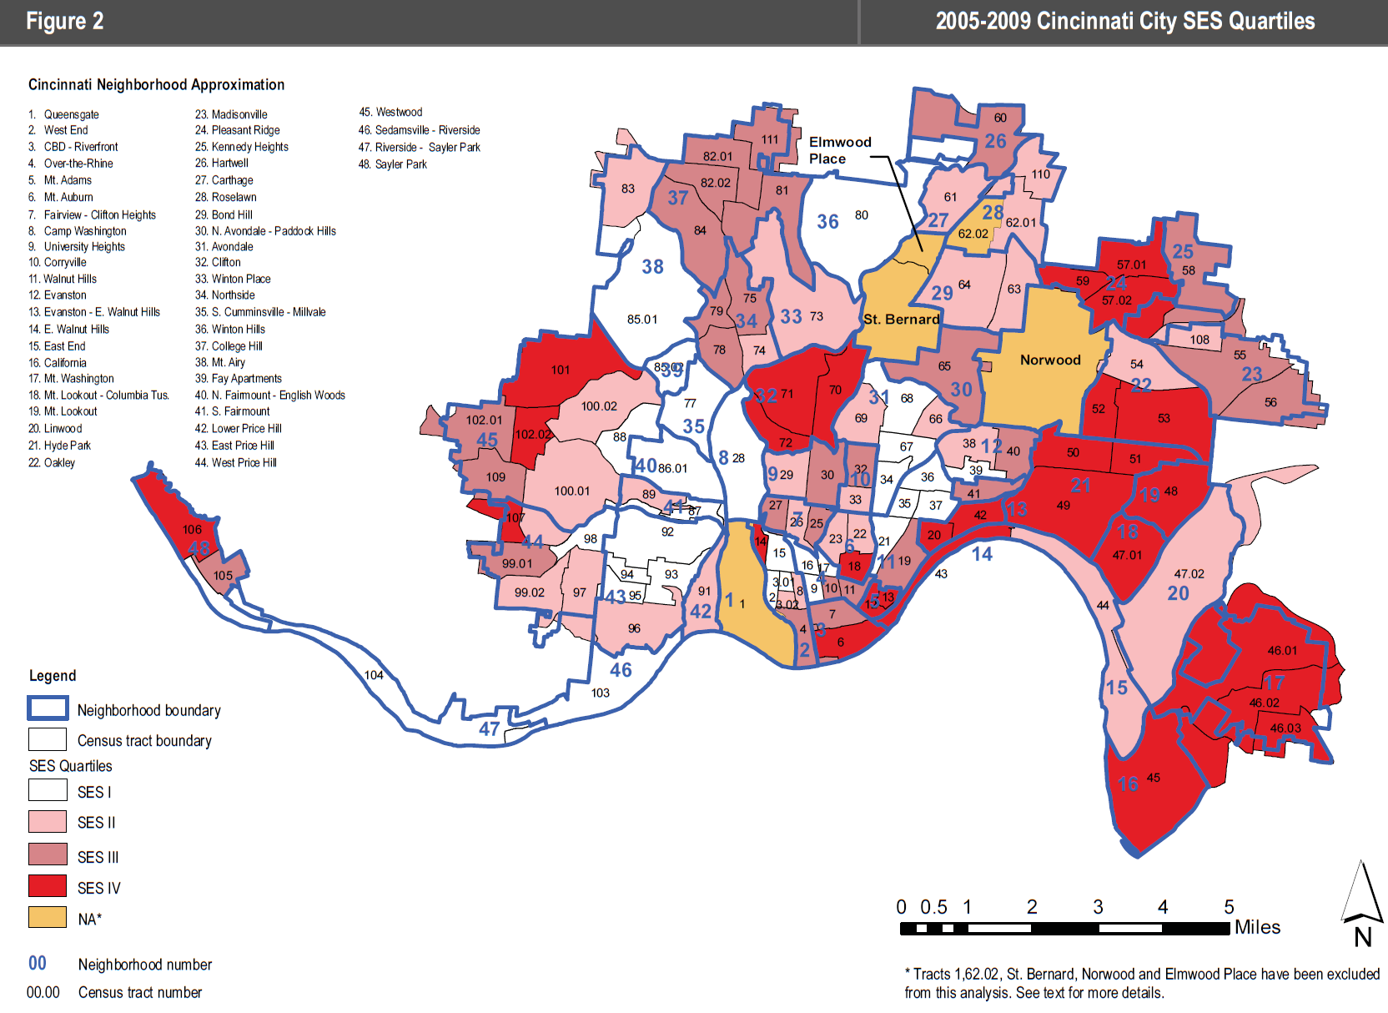

Table 5: Covid-19 Virus Confirmed Cases by Neighborhood
 | Case Count |  |  |  |  | Case Count
Neighborhood | 1-Jun | 7-Jul | 13-Aug | 14-Sep | %Inc | Neighborhood | 1-Jun | 7-Jul | 13-Aug | 14-Sep | %Inc
Queensgate | 2 | 2 | 3 | 3 | 50.00% | Roselawn | 20 | 65 | 114 | 125 | 525.00%
West End | 13 | 63 | 95 | 106 | 715.38% | Bond Hill | 29 | 93 | 132 | 140 | 382.76%
CBD-Riverfront | 9 | 38 | 105 | 119 | 1222.22% | N. Avondale – Paddock Hills | 7 | 25 | 51 | 57 | 714.29%
Over-the-Rhine | 7 | 50 | 85 | 93 | 1228.57% | Avondale | 47 | 122 | 186 | 220 | 368.09%
Mt. Adams | 0 | 4 | 8 | 12 | #DIV/0! | Clifton | 18 | 38 | 70 | 81 | 350.00%
Mt. Auburn | 11 | 39 | 69 | 85 | 672.73% | Spring Grove Village | 5 | 17 | 25 | 26 | 420.00%
Clifton/University Heights—Fairview (CUF) | 9 | 45 | 128 | 376 | 4077.78% | Northside | 17 | 43 | 70 | 85 | 400.00%
Camp Washington | 2 | 6 | 20 | 22 | 1000.00% | S. Cumminsville | 3 | 9 | 12 | 15 | 400.00%
Corryville | 3 | 13 | 31 | 90 | 2900.00% | Winton Hills | 12 | 34 | 52 | 56 | 366.67%
Evanston | 19 | 61 | 106 | 127 | 568.42% | College Hill | 45 | 162 | 229 | 261 | 480.00%
E. Walnut Hills | 8 | 18 | 34 | 41 | 412.50% | Mt. Airy | 40 | 127 | 190 | 206 | 415.00%
Walnut Hills | 20 | 56 | 84 | 95 | 375.00% | Villages at Roll Hill | 3 | 22 | 29 | 32 | 966.67%
East End | 0 | 2 | 6 | 9 | #DIV/0! | N. Fairmount | 5 | 19 | 24 | 25 | 400.00%
California | 0 | 1 | 1 | 2 | #DIV/0! | S. Fairmount | 3 | 32 | 45 | 47 | 1466.67%
Mt. Washington | 27 | 55 | 86 | 114 | 322.22% | Lower Price Hill | 8 | 16 | 18 | 18 | 125.00%
Columbia-Tusculum | 1 | 2 | 6 | 11 | 1000.00% | East Price Hill | 154 | 224 | 272 | 293 | 90.26%
Mt. Lookout | 9 | 14 | 35 | 65 | 622.22% | West Price Hill | 114 | 198 | 292 | 325 | 185.09%
Linwood | 1 | 2 | 3 | 3 | 200.00% | Westwood | 209 | 451 | 617 | 692 | 231.10%
Hyde Park | 20 | 35 | 92 | 140 | 600.00% | Sedamsville | 2 | 3 | 7 | 7 | 250.00%
Oakley | 29 | 56 | 114 | 159 | 448.28% | Sayler Park | 1 | 9 | 21 | 39 | 3800.00%
Madisonville | 18 | 56 | 108 | 118 | 555.56% | East Westwood | 21 | 40 | 52 | 53 | 152.38%
Pleasant Ridge | 60 | 84 | 108 | 121 | 101.67% | Pendleton | 0 | 7 | 17 | 20 | NA
Kennedy Heights | 20 | 45 | 69 | 76 | 280.00% | English Woods | 1 | 1 | 2 | 5 | 400.00%
Hartwell | 42 | 78 | 105 | 108 | 157.14% | Riverside | 3 | 5 | 14 | 19 | 533.33%
Carthage | 11 | 23 | 29 | 33 | 200.00% | Millvale | 2 | 11 | 17 | 18 | 800.00%
Source: Cincinnati Health Department June 1, July 7, August 13, September 14
Table 5 shows the trends in the entire list of Cincinnati neighborhoods. The author will provide periodic updates.

Michael Maloney is Convener of the Urban Appalachian Community Coalition, a community organizer and social researcher. His publications include the five editions of the Social Areas of Cincinnati: Analysis of Social Needs (vols. 4-5 with Christopher Auffrey).

