Entering the Third Wave: The Geography and Demographics of the Coronavirus in Cincinnati

November 14, 2020

Introduction
The Cincinnati Health Department has been tracking the Coronavirus by neighborhood, age, gender, and race since March 23. An interactive map and charts are updated each day (https://www.cincinnati-oh.gov/health/covid-19/. We felt it was important to plot the data at discrete times and look for trends and anomalies. I have also been monitoring the availability of testing sites in different sections of the city. (If there is no testing, it affects the data.) In this edition, we have added a section which shows the evolution of the virus as it goes into its third surge and makes suggestions for public response.

Demography of Covid Deaths and Confirmed Cases

Race and Ethnicity
Table 1 shows the distribution of deaths and confirmed cases at approximately monthly intervals from June 1 to November 14. During that period, black deaths increased from 24 to 59 (145.8%). White deaths increased from 20 to 46 (130%). Hispanic deaths increased from 0 to 1. Note that race and ethnicity are not always recorded. As of November 14, the number of unknown deaths had increased to 13 (109.0%).
The picture in Table 1 is similar for confirmed cases of Covid 19. Since June 1, the number of black cases had increased from 368 to 3,233 (778.5%) and the number of white cases increased from 324 to 3,636 (1022.2%). The number of Hispanic cases had increased from 195 to 356 (82.6%). Table 1 also shows the percent increase for each group since June 1.
Table 1: Deaths and Confirmed Cases by Race and Ethnicity
 | Deaths |  |  |  |  | Cases
Race | 1-Jun | 14-Oct | 14-Nov | %Inc  (month) | %Inc  (since 6/1) | 1-Jun | 14-Oct | 14-Nov | %Inc  (month) | %Inc  (since 6/1)
Black | 24 | 55 | 59 | 7.3% | 145.8% | 368 | 2,554 | 3,233 | 26.6% | 778.5%
Hispanic | 0 | 1 | 1 | 0.0% | NA | 195 | 355 | 356 | 0.3% | 82.6%
White | 20 | 42 | 46 | 9.5% | 130.0% | 324 | 2,338 | 3,636 | 55.5% | 1022.2%
Other | 3 | 5 | 5 | 0.0% | 66.7% | 77 | 284 | 445 | 56.7% | 477.9%
Unknown | 5 | 8 | 13 | 62.5% | 160.0% | 165 | 795 | 1562 | 96.5% | 846.7%
Total | 52 | 111 | 124 | 11.7% | 138.5% | 1,129 | 6,326 | 9,232 | 45.9% | 717.7%
Source: Cincinnati Health Department, June 1, July 7, October 14, November 14
Only 35.0% of confirmed cases were black compared to 39.4% which are white. The percentage of race unknown cases grew from 14.6% to 16.9% from June to November and the number of unknown cases grew by about 100% (767 cases) in the past month. There is still a problem with recording the race and ethnicity of Covid cases and it is growing.
Table 2: Deaths and Confirmed Cases by Population
 | Expected % | Deaths (Actual %) |  |  | Cases (Actual %)
Race |  | 1-Jun | 14-Oct | 14-Nov | 1-Jun | 14-Oct | 14-Nov
Black | 42.7 | 46.2 | 49.5% | 47.6% | 32.6 | 40.4% | 35.0%
Hispanic | 3.7 | 0 | 0.9% | 0.8% | 17.3 | 5.6% | 3.9%
White | 48.2 | 38.5 | 37.8% | 37.1% | 28.7 | 37.0% | 39.4%
Other | 5.4 | 5.8 | 4.5% | 4.0% | 6.8 | 4.5% | 4.8%
Unknown | NA | 9.6 | 7.2% | 10.5% | 14.6 | 12.6% | 16.9%
Source: Cincinnati Health Department June 1, October 14, November 14
Blacks in Cincinnati are more likely to die from the virus than whites but the disparity is not increasing over time.

Age
Table 3 shows that the number of deaths as of November 14 is still highest in the older age ranges. There are no recorded deaths for the under 30 population and only 2 in the under 40 population. During the first surge, the numbers of cases and percentages of increase really jumped in the younger population groups. However, in the fall surge dramatic increases have occurred across the age groups, but especially among the 40-80 age range. The largest percent increase as of November 14 was in the 60-69 age group at 59% -- still only 387 cases though, out of 9,215. The 70-79 group jumped by 57%. The virus is not killing our young people but is surging among the 20-60 population. The experts are concerned about possible long term effects of the virus on young people.
Table 3: Age Distribution of Deaths and Confirmed Cases
Age Group | 1-Jun | 14-Oct | 14-Nov | % Inc (since June) | % Inc (month) | 1-Jun | 14-Oct | 14-Nov | % Inc (since June) | % Inc (month)
0-9 | 0 | 0 | 0 | NA | NA | 22 | 164 | 231 | 950% | 41%
10-19 | 0 | 0 | 0 | NA | NA | 42 | 769 | 1029 | 2350% | 34%
20-29 | 0 | 0 | 0 | NA | NA | 172 | 1899 | 2762 | 1506% | 45%
30-39 | 1 | 2 | 2 | 100% | 0% | 251 | 1150 | 1640 | 553% | 43%
40-49 | 1 | 6 | 5 | 400% | -17% | 160 | 659 | 981 | 513% | 49%
50-59 | 3 | 8 | 9 | 200% | 13% | 158 | 684 | 1058 | 570% | 55%
60-69 | 12 | 26 | 33 | 175% | 27% | 134 | 517 | 822 | 513% | 59%
70-79 | 5 | 20 | 23 | 360% | 15% | 79 | 246 | 387 | 390% | 57%
80-89 | 16 | 25 | 28 | 75% | 12% | 73 | 152 | 205 | 181% | 35%
90-99 | 11 | 20 | 20 | 82% | 0% | 35 | 74 | 94 | 169% | 27%
100 – | 3 | 4 | 4 | 33% | 0% | 3 | 5 | 6 | 100% | 20%
Total | 52 | 111 | 124 | 138.5% | 12% | 1,129 | 6,319 | 9,215 | 716.2% | 45.8%
Source: Cincinnati Health Department June 1, October 14, November 14

Sex
As of November 14, there have been 4,269 confirmed cases among males and 4,963 among females. The deaths were 64 male and 60 female.
Table 3a: Deaths and Confirmed Cases by Sex
Deaths |  | Cases
Male | Female | Male | Female
64 | 60 | 4,269 | 4,963
Source: Cincinnati Health Department, November 14

Neighborhood Distribution
Table 4 shows the neighborhoods with the highest numbers of cases. These fourteen neighborhoods have large populations but some also have minority populations, significant poverty rates and high numbers of cases per capita. Five are on the west side of the city. As of November 14, these neighborhoods had 57.7% of Cincinnati’s confirmed Covid-19 cases. Table 4 also shows some of the other neighborhoods with largest increases in confirmed cases between June 1 and November 14. Those twelve neighborhoods are mostly on the East Side and they all have more than 100 confirmed cases.
Table 4: Hot Spots
Large Number of Cases |  |  |  | Other Neighborhoods with over  100 Cases as of November 14
 | 1-Jun | 14-Oct | 14-Nov |  | 1-Jun | 14-Oct | 14-Nov
Westwood | 209 | 757 | 947 | Madisonville | 18 | 159 | 249
CUF | 17 | 583 | 720 | Pleasant Ridge | 60 | 143 | 186
West Price Hill | 114 | 384 | 557 | Corryville | 3 | 138 | 177
East Price Hill | 154 | 312 | 379 | Hartwell | 42 | 120 | 153
College Hill | 45 | 296 | 382 | Over-the-Rhine | 7 | 111 | 174
Avondale | 47 | 243 | 289 | Walnut Hills | 20 | 108 | 147
Mt.Airy | 40 | 226 | 277 | Mt. Auburn | 11 | 103 | 143
Oakley | 29 | 215 | 345 | West End | 13 | 114 | 130
CBD/Riverfront | 9 | 166 | 240 | Mt. Lookout | 9 | 88 | 117
Evanston | 19 | 181 | 237 | Kennedy Heights | 20 | 92 | 116
Mt. Washington | 27 | 146 | 212 | Clifton | 18 | 91 | 139
Roselawn | 20 | 145 | 213 | Northside | 17 | 89 | 139
Bond Hill | 29 | 158 | 204
Hyde Park | 20 | 205 | 316
Source: Cincinnati Health Department June 1, October 14, November 14

Conclusions
The data presented in this report need to be considered in the location of testing sites and in the allocation of outreach, contact tracing, and education resources. The neighborhoods listed in Table 4 should be top priority. Second priority should be the low socio-economic status areas (SES I) listed in the socioeconomic status map (Figure 2 from The Social Areas of Cincinnati, Fifth Edition (www.socialareasofcincinnati.org)). This will include, for example, impoverished sections of the West End, Lower Price Hill, Sedamsville, the Mill Creek Valley and the near east side along Reading Road and Montgomery Road. Some of these neighborhoods, though their numbers are small, show up in Table 5 with very high percent increases in confirmed cases:
Sayler Park 7600%
South Fairmount 1700%
Villages at Roll Hill 1200%
Millvale 1400%
As testing becomes more widespread, we can perhaps expect the highest percent increases will continue to be in this category of neighborhoods.

The Third Wave: Description and Advice

We are in the midst of a serious spike in Covid-19 cases in southwest Ohio. I have been monitoring data on the CinciInsights page, where indicators suggest the extent of the spike and the danger to the community. With winter coming on, there is much to be concerned about.
The daily new cases figure indicates the extent of infectious cases in the community. Whereas total cases includes many that are not a danger to the community (recovered, quarantined, hospitalized, or deceased), new cases are those recently diagnosed. The figures are averaged over seven days to counter the effects of outliers, such as dips on weekends when there is less testing. The curve for the recent spike is alarmingly steep and is showing no signs of peaking. The current weekly average is twice what it was during the summer spike.
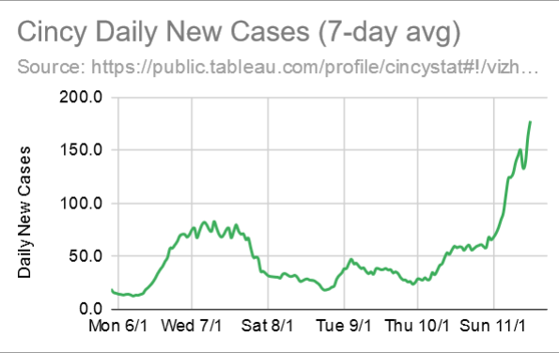

The other indicator is wastewater surveillance, which measures non-infectious Covid RNA in sewage processed in wastewater treatment plants. The Ohio Department of Health reports wastewater surveillance for three Cincinnati sites; the graph below represents the Mill Creek station which serves the central sector. The advantage of wastewater surveillance is that it includes everyone and can detect changes sooner than diagnostic testing. It is far less sensitive, however, and only responds to dramatic changes in community infection. The graph shows that wastewater figures didn’t budge during the summer wave, but have reached frightening levels in recent weeks.
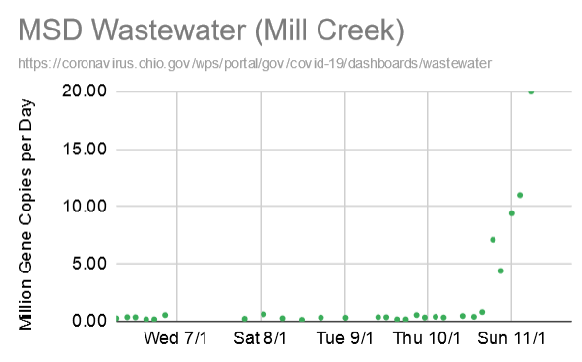

The Cincinnati Covid dashboard also reports large gathering infection locales derived from contact tracer reports. The current most infectious sites are retail stores (21%); restaurants (13%); schools, daycare, childcare (13%); family, friends, party (9%); bars, nightclubs (8%). (To view the full list, visit the CincyInsights: page, then click the “Large Gathering” link at the top.)
Unlike the previous spikes in April and July, there seems to be less public will for preventive strategies. Wearing masks in indoor public spaces such as stores should be universal, but there remain holdouts among both employees and patrons. There is widespread recognition of indoor aerosol transmission that should suggest determined effort and policy limiting indoor contact.
We have greater access to testing now and vastly more knowledge about the disease than in the spring. As we have seen from the cases in the White House, however, even the most rigorous testing regimen will not prevent infections. The idea is to reduce risk using a combination of measures—testing, sanitary precautions, and avoidance of contact.
On November 16, 2020, the state of Ohio began enforcing a health order requiring masks in retail locations across the state. Citizens observing non-compliance should notify the Ohio Department of Health call center at 1-833-4ASKODH (1-833-427-5634). The Cincinnati Department of Health also has a hotline for reporting business violations—513-357-7462 or COVID.complaint@cincinnati-oh.gov.

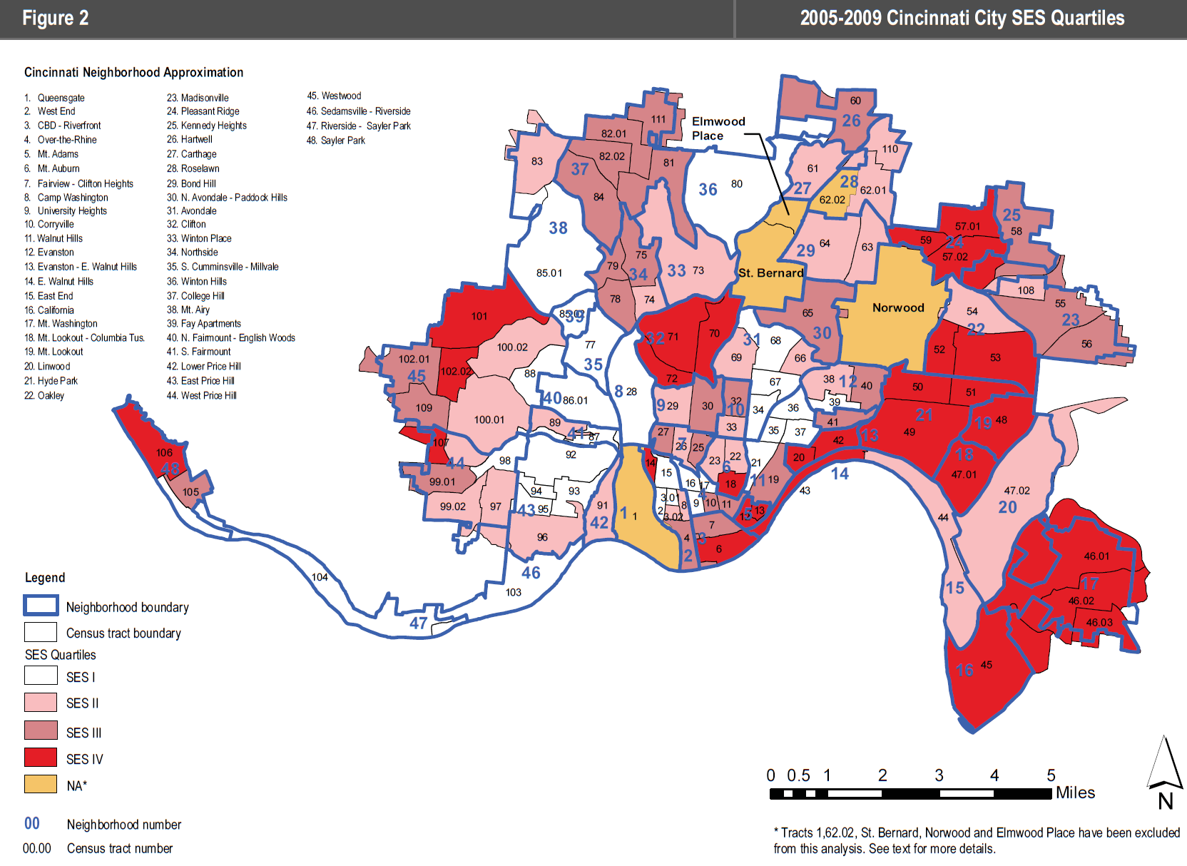
Table 5: Covid-19 Virus Confirmed Cases by Neighborhood
 | Case Count |  |  |  |  | Case Count
Neighborhood | 1-Jun | 14-Oct | 14-Nov | %Inc  Since June | %Inc  (Month) | Neighborhood | 1-Jun | 14-Oct | 14-Nov | %Inc  Since June | %Inc  (Month)
Queensgate | 2 | 4 | 6 | 200.00% | 50.00% | Roselawn | 20 | 145 | 213 | 965.00% | 46.90%
West End | 13 | 114 | 130 | 900.00% | 14.04% | Bond Hill | 29 | 158 | 204 | 603.45% | 29.11%
CBD-Riverfront | 9 | 166 | 240 | 2566.67% | 44.58% | N. Avondale – Paddock Hills | 7 | 65 | 87 | 1142.86% | 33.85%
Over-the-Rhine | 7 | 111 | 174 | 2385.71% | 56.76% | Avondale | 47 | 243 | 289 | 514.89% | 18.93%
Mt. Adams | 0 | 25 | 41 | NA | 64.00% | Clifton | 18 | 91 | 139 | 672.22% | 52.75%
Mt. Auburn | 11 | 103 | 143 | 1200.00% | 38.83% | Spring Grove Village | 5 | 30 | 47 | 840.00% | 56.67%
Clifton/University Heights—Fairview (CUF) | 9 | 583 | 720 | 7900.00% | 23.50% | Northside | 17 | 89 | 139 | 717.65% | 56.18%
Camp Washington | 2 | 22 | 35 | 1650.00% | 59.09% | S. Cumminsville | 3 | 16 | 26 | 766.67% | 62.50%
Corryville | 3 | 138 | 177 | 5800.00% | 28.26% | Winton Hills | 12 | 64 | 78 | 550.00% | 21.88%
Evanston | 19 | 181 | 237 | 1147.37% | 30.94% | College Hill | 45 | 296 | 382 | 748.89% | 29.05%
E. Walnut Hills | 8 | 57 | 85 | 962.50% | 49.12% | Mt. Airy | 40 | 226 | 277 | 592.50% | 22.57%
Walnut Hills | 20 | 108 | 147 | 635.00% | 36.11% | Villages at Roll Hill | 3 | 32 | 39 | 1200.00% | 21.88%
East End | 0 | 10 | 21 | NA | 110.00% | N. Fairmount | 5 | 29 | 34 | 580.00% | 17.24%
California | 0 | 2 | 6 | NA | 200.00% | S. Fairmount | 3 | 48 | 54 | 1700.00% | 12.50%
Mt. Washington | 27 | 146 | 212 | 685.19% | 45.21% | Lower Price Hill | 8 | 18 | 19 | 137.50% | 5.56%
Columbia-Tusculum | 1 | 20 | 30 | 2900.00% | 50.00% | East Price Hill | 154 | 312 | 379 | 146.10% | 21.47%
Mt. Lookout | 9 | 88 | 117 | 1200.00% | 32.95% | West Price Hill | 114 | 384 | 557 | 388.60% | 45.05%
Linwood | 1 | 6 | 9 | 800.00% | 50.00% | Westwood | 209 | 757 | 947 | 353.11% | 25.10%
Hyde Park | 20 | 205 | 316 | 1480.00% | 54.15% | Sedamsville | 2 | 8 | 12 | 500.00% | 50.00%
Oakley | 29 | 215 | 345 | 1089.66% | 60.47% | Sayler Park | 1 | 55 | 77 | 7600.00% | 40.00%
Madisonville | 18 | 159 | 249 | 1283.33% | 56.60% | East Westwood | 21 | 56 | 65 | 209.52% | 16.07%
Pleasant Ridge | 60 | 143 | 186 | 210.00% | 30.07% | Pendleton | 0 | 21 | 41 | NA | 95.24%
Kennedy Heights | 20 | 92 | 116 | 480.00% | 26.09% | English Woods | 1 | 7 | 8 | 700.00% | 14.29%
Hartwell | 42 | 120 | 153 | 264.29% | 27.50% | Riverside | 3 | 23 | 45 | 1400.00% | 95.65%
Carthage | 11 | 41 | 60 | 445.45% | 46.34% | Millvale | 2 | 20 | 30 | 1400.00% | 50.00%
Source: Cincinnati Health Department June 1, July 7, October 14, November 14
Table 5 shows the trends in the entire list of Cincinnati neighborhoods. The author will provide periodic updates.

Michael Maloney is Convener of the Urban Appalachian Community Coalition, a community organizer and social researcher. His publications include the five editions of the Social Areas of Cincinnati: Analysis of Social Needs (vols. 4-5 with Christopher Auffrey).
John Bealle is an independent scholar and chair of the Urban Appalachian Community Coalition’s Communications Committee.

Appendix
Neighborhoods Sorted by October to November Increase
Neighborhood | 1-Jun | 7-Jul | 13-Aug | 14-Sep | 14-Oct | 14-Nov | %Inc  Since June | %Inc  (Month)
California | - | 1 | 1 | 2 | 2 | 6 | NA | 200%
East End | - | 2 | 6 | 9 | 10 | 21 | NA | 110%
Riverside | 3 | 5 | 14 | 19 | 23 | 45 | 1400% | 96%
Pendleton | - | 7 | 17 | 20 | 21 | 41 | NA | 95%
Mt. Adams | - | 4 | 8 | 12 | 25 | 41 | NA | 64%
S. Cumminsville | 3 | 9 | 12 | 15 | 16 | 26 | 767% | 63%
Oakley | 29 | 56 | 114 | 159 | 215 | 345 | 1090% | 60%
Camp Washington | 2 | 6 | 20 | 22 | 22 | 35 | 1650% | 59%
Over-the-Rhine | 7 | 50 | 85 | 93 | 111 | 174 | 2386% | 57%
Spring Grove Village | 5 | 17 | 25 | 26 | 30 | 47 | 840% | 57%
Madisonville | 18 | 56 | 108 | 118 | 159 | 249 | 1283% | 57%
Northside | 17 | 43 | 70 | 85 | 89 | 139 | 718% | 56%
Hyde Park | 20 | 35 | 92 | 140 | 205 | 316 | 1480% | 54%
Clifton | 18 | 38 | 70 | 81 | 91 | 139 | 672% | 53%
Queensgate | 2 | 2 | 3 | 3 | 4 | 6 | 200% | 50%
Columbia-Tusculum | 1 | 2 | 6 | 11 | 20 | 30 | 2900% | 50%
Linwood | 1 | 2 | 3 | 3 | 6 | 9 | 800% | 50%
Sedamsville | 2 | 3 | 7 | 7 | 8 | 12 | 500% | 50%
Millvale | 2 | 11 | 17 | 18 | 20 | 30 | 1400% | 50%
E. Walnut Hills | 8 | 18 | 34 | 41 | 57 | 85 | 963% | 49%
Roselawn | 20 | 65 | 114 | 125 | 145 | 213 | 965% | 47%
Carthage | 11 | 23 | 29 | 33 | 41 | 60 | 445% | 46%
Mt. Washington | 27 | 55 | 86 | 114 | 146 | 212 | 685% | 45%
West Price Hill | 114 | 198 | 292 | 325 | 384 | 557 | 389% | 45%
CBD-Riverfront | 9 | 38 | 105 | 119 | 166 | 240 | 2567% | 45%
Sayler Park | 1 | 9 | 21 | 39 | 55 | 77 | 7600% | 40%
Mt. Auburn | 11 | 39 | 69 | 85 | 103 | 143 | 1200% | 39%
Walnut Hills | 20 | 56 | 84 | 95 | 108 | 147 | 635% | 36%
N. Avondale – Paddock Hills | 7 | 25 | 51 | 57 | 65 | 87 | 1143% | 34%
Mt. Lookout | 9 | 14 | 35 | 65 | 88 | 117 | 1200% | 33%
Evanston | 19 | 61 | 106 | 127 | 181 | 237 | 1147% | 31%
Pleasant Ridge | 60 | 84 | 108 | 121 | 143 | 186 | 210% | 30%
Bond Hill | 29 | 93 | 132 | 140 | 158 | 204 | 603% | 29%
College Hill | 45 | 162 | 229 | 261 | 296 | 382 | 749% | 29%
Corryville | 3 | 13 | 31 | 90 | 138 | 177 | 5800% | 28%
Hartwell | 42 | 78 | 105 | 108 | 120 | 153 | 264% | 28%
Kennedy Heights | 20 | 45 | 69 | 76 | 92 | 116 | 480% | 26%
Westwood | 209 | 451 | 617 | 692 | 757 | 947 | 353% | 25%
Clifton/University Heights—Fairview (CUF) | 9 | 45 | 128 | 376 | 583 | 720 | 7900% | 23%
Mt. Airy | 40 | 127 | 190 | 206 | 226 | 277 | 593% | 23%
Winton Hills | 12 | 34 | 52 | 56 | 64 | 78 | 550% | 22%
Villages at Roll Hill | 3 | 22 | 29 | 32 | 32 | 39 | 1200% | 22%
East Price Hill | 154 | 224 | 272 | 293 | 312 | 379 | 146% | 21%
Avondale | 47 | 122 | 186 | 220 | 243 | 289 | 515% | 19%
N. Fairmount | 5 | 19 | 24 | 25 | 29 | 34 | 580% | 17%
East Westwood | 21 | 40 | 52 | 53 | 56 | 65 | 210% | 16%
English Woods | 1 | 1 | 2 | 5 | 7 | 8 | 700% | 14%
West End | 13 | 63 | 95 | 106 | 114 | 130 | 900% | 14%
S. Fairmount | 3 | 32 | 45 | 47 | 48 | 54 | 1700% | 13%
Lower Price Hill | 8 | 16 | 18 | 18 | 18 | 19 | 138% | 6%

Neighborhoods Sorted by June to November Increase
Neighborhood | 1-Jun | 7-Jul | 13-Aug | 14-Sep | 14-Oct | 14-Nov | %Inc  Since June | %Inc  (Month)
California | 0 | 1 | 1 | 2 | 2 | 6 | NA | 200.00%
East End | 0 | 2 | 6 | 9 | 10 | 21 | NA | 110.00%
Pendleton | 0 | 7 | 17 | 20 | 21 | 41 | NA | 95.24%
Mt. Adams | 0 | 4 | 8 | 12 | 25 | 41 | NA | 64.00%
Clifton/University Heights—Fairview (CUF) | 9 | 45 | 128 | 376 | 583 | 720 | 7900.00% | 23.50%
Sayler Park | 1 | 9 | 21 | 39 | 55 | 77 | 7600.00% | 40.00%
Corryville | 3 | 13 | 31 | 90 | 138 | 177 | 5800.00% | 28.26%
Columbia-Tusculum | 1 | 2 | 6 | 11 | 20 | 30 | 2900.00% | 50.00%
CBD-Riverfront | 9 | 38 | 105 | 119 | 166 | 240 | 2566.67% | 44.58%
Over-the-Rhine | 7 | 50 | 85 | 93 | 111 | 174 | 2385.71% | 56.76%
S. Fairmount | 3 | 32 | 45 | 47 | 48 | 54 | 1700.00% | 12.50%
Camp Washington | 2 | 6 | 20 | 22 | 22 | 35 | 1650.00% | 59.09%
Hyde Park | 20 | 35 | 92 | 140 | 205 | 316 | 1480.00% | 54.15%
Riverside | 3 | 5 | 14 | 19 | 23 | 45 | 1400.00% | 95.65%
Millvale | 2 | 11 | 17 | 18 | 20 | 30 | 1400.00% | 50.00%
Madisonville | 18 | 56 | 108 | 118 | 159 | 249 | 1283.33% | 56.60%
Mt. Auburn | 11 | 39 | 69 | 85 | 103 | 143 | 1200.00% | 38.83%
Mt. Lookout | 9 | 14 | 35 | 65 | 88 | 117 | 1200.00% | 32.95%
Villages at Roll Hill | 3 | 22 | 29 | 32 | 32 | 39 | 1200.00% | 21.88%
Evanston | 19 | 61 | 106 | 127 | 181 | 237 | 1147.37% | 30.94%
N. Avondale – Paddock Hills | 7 | 25 | 51 | 57 | 65 | 87 | 1142.86% | 33.85%
Oakley | 29 | 56 | 114 | 159 | 215 | 345 | 1089.66% | 60.47%
Roselawn | 20 | 65 | 114 | 125 | 145 | 213 | 965.00% | 46.90%
E. Walnut Hills | 8 | 18 | 34 | 41 | 57 | 85 | 962.50% | 49.12%
West End | 13 | 63 | 95 | 106 | 114 | 130 | 900.00% | 14.04%
Spring Grove Village | 5 | 17 | 25 | 26 | 30 | 47 | 840.00% | 56.67%
Linwood | 1 | 2 | 3 | 3 | 6 | 9 | 800.00% | 50.00%
S. Cumminsville | 3 | 9 | 12 | 15 | 16 | 26 | 766.67% | 62.50%
College Hill | 45 | 162 | 229 | 261 | 296 | 382 | 748.89% | 29.05%
Northside | 17 | 43 | 70 | 85 | 89 | 139 | 717.65% | 56.18%
English Woods | 1 | 1 | 2 | 5 | 7 | 8 | 700.00% | 14.29%
Mt. Washington | 27 | 55 | 86 | 114 | 146 | 212 | 685.19% | 45.21%
Clifton | 18 | 38 | 70 | 81 | 91 | 139 | 672.22% | 52.75%
Walnut Hills | 20 | 56 | 84 | 95 | 108 | 147 | 635.00% | 36.11%
Bond Hill | 29 | 93 | 132 | 140 | 158 | 204 | 603.45% | 29.11%
Mt. Airy | 40 | 127 | 190 | 206 | 226 | 277 | 592.50% | 22.57%
N. Fairmount | 5 | 19 | 24 | 25 | 29 | 34 | 580.00% | 17.24%
Winton Hills | 12 | 34 | 52 | 56 | 64 | 78 | 550.00% | 21.88%
Avondale | 47 | 122 | 186 | 220 | 243 | 289 | 514.89% | 18.93%
Sedamsville | 2 | 3 | 7 | 7 | 8 | 12 | 500.00% | 50.00%
Kennedy Heights | 20 | 45 | 69 | 76 | 92 | 116 | 480.00% | 26.09%
Carthage | 11 | 23 | 29 | 33 | 41 | 60 | 445.45% | 46.34%
West Price Hill | 114 | 198 | 292 | 325 | 384 | 557 | 388.60% | 45.05%
Westwood | 209 | 451 | 617 | 692 | 757 | 947 | 353.11% | 25.10%
Hartwell | 42 | 78 | 105 | 108 | 120 | 153 | 264.29% | 27.50%
Pleasant Ridge | 60 | 84 | 108 | 121 | 143 | 186 | 210.00% | 30.07%
East Westwood | 21 | 40 | 52 | 53 | 56 | 65 | 209.52% | 16.07%
Queensgate | 2 | 2 | 3 | 3 | 4 | 6 | 200.00% | 50.00%
East Price Hill | 154 | 224 | 272 | 293 | 312 | 379 | 146.10% | 21.47%
Lower Price Hill | 8 | 16 | 18 | 18 | 18 | 19 | 137.50% | 5.56%

Neighborhoods Sorted Alphabetically
Neighborhood | 1-Jun | 7-Jul | 13-Aug | 14-Sep | 14-Oct | 14-Nov | %Inc  Since June | %Inc  (Month)
Avondale | 47 | 122 | 186 | 220 | 243 | 289 | 514.89% | 18.93%
Bond Hill | 29 | 93 | 132 | 140 | 158 | 204 | 603.45% | 29.11%
California | 0 | 1 | 1 | 2 | 2 | 6 | NA | 200.00%
Camp Washington | 2 | 6 | 20 | 22 | 22 | 35 | 1650.00% | 59.09%
Carthage | 11 | 23 | 29 | 33 | 41 | 60 | 445.45% | 46.34%
CBD-Riverfront | 9 | 38 | 105 | 119 | 166 | 240 | 2566.67% | 44.58%
Clifton | 18 | 38 | 70 | 81 | 91 | 139 | 672.22% | 52.75%
Clifton/University Heights—Fairview (CUF) | 9 | 45 | 128 | 376 | 583 | 720 | 7900.00% | 23.50%
College Hill | 45 | 162 | 229 | 261 | 296 | 382 | 748.89% | 29.05%
Columbia-Tusculum | 1 | 2 | 6 | 11 | 20 | 30 | 2900.00% | 50.00%
Corryville | 3 | 13 | 31 | 90 | 138 | 177 | 5800.00% | 28.26%
E. Walnut Hills | 8 | 18 | 34 | 41 | 57 | 85 | 962.50% | 49.12%
East End | 0 | 2 | 6 | 9 | 10 | 21 | NA | 110.00%
East Price Hill | 154 | 224 | 272 | 293 | 312 | 379 | 146.10% | 21.47%
East Westwood | 21 | 40 | 52 | 53 | 56 | 65 | 209.52% | 16.07%
English Woods | 1 | 1 | 2 | 5 | 7 | 8 | 700.00% | 14.29%
Evanston | 19 | 61 | 106 | 127 | 181 | 237 | 1147.37% | 30.94%
Hartwell | 42 | 78 | 105 | 108 | 120 | 153 | 264.29% | 27.50%
Hyde Park | 20 | 35 | 92 | 140 | 205 | 316 | 1480.00% | 54.15%
Kennedy Heights | 20 | 45 | 69 | 76 | 92 | 116 | 480.00% | 26.09%
Linwood | 1 | 2 | 3 | 3 | 6 | 9 | 800.00% | 50.00%
Lower Price Hill | 8 | 16 | 18 | 18 | 18 | 19 | 137.50% | 5.56%
Madisonville | 18 | 56 | 108 | 118 | 159 | 249 | 1283.33% | 56.60%
Millvale | 2 | 11 | 17 | 18 | 20 | 30 | 1400.00% | 50.00%
Mt. Adams | 0 | 4 | 8 | 12 | 25 | 41 | NA | 64.00%
Mt. Airy | 40 | 127 | 190 | 206 | 226 | 277 | 592.50% | 22.57%
Mt. Auburn | 11 | 39 | 69 | 85 | 103 | 143 | 1200.00% | 38.83%
Mt. Lookout | 9 | 14 | 35 | 65 | 88 | 117 | 1200.00% | 32.95%
Mt. Washington | 27 | 55 | 86 | 114 | 146 | 212 | 685.19% | 45.21%
N. Avondale – Paddock Hills | 7 | 25 | 51 | 57 | 65 | 87 | 1142.86% | 33.85%
N. Fairmount | 5 | 19 | 24 | 25 | 29 | 34 | 580.00% | 17.24%
Northside | 17 | 43 | 70 | 85 | 89 | 139 | 717.65% | 56.18%
Oakley | 29 | 56 | 114 | 159 | 215 | 345 | 1089.66% | 60.47%
Over-the-Rhine | 7 | 50 | 85 | 93 | 111 | 174 | 2385.71% | 56.76%
Pendleton | 0 | 7 | 17 | 20 | 21 | 41 | NA | 95.24%
Pleasant Ridge | 60 | 84 | 108 | 121 | 143 | 186 | 210.00% | 30.07%
Queensgate | 2 | 2 | 3 | 3 | 4 | 6 | 200.00% | 50.00%
Riverside | 3 | 5 | 14 | 19 | 23 | 45 | 1400.00% | 95.65%
Roselawn | 20 | 65 | 114 | 125 | 145 | 213 | 965.00% | 46.90%
S. Cumminsville | 3 | 9 | 12 | 15 | 16 | 26 | 766.67% | 62.50%
S. Fairmount | 3 | 32 | 45 | 47 | 48 | 54 | 1700.00% | 12.50%
Sayler Park | 1 | 9 | 21 | 39 | 55 | 77 | 7600.00% | 40.00%
Sedamsville | 2 | 3 | 7 | 7 | 8 | 12 | 500.00% | 50.00%
Spring Grove Village | 5 | 17 | 25 | 26 | 30 | 47 | 840.00% | 56.67%
Villages at Roll Hill | 3 | 22 | 29 | 32 | 32 | 39 | 1200.00% | 21.88%
Walnut Hills | 20 | 56 | 84 | 95 | 108 | 147 | 635.00% | 36.11%
West End | 13 | 63 | 95 | 106 | 114 | 130 | 900.00% | 14.04%
West Price Hill | 114 | 198 | 292 | 325 | 384 | 557 | 388.60% | 45.05%
Westwood | 209 | 451 | 617 | 692 | 757 | 947 | 353.11% | 25.10%
Winton Hills | 12 | 34 | 52 | 56 | 64 | 78 | 550.00% | 21.88%

