The Geography and Demographics of the Coronavirus in Cincinnati

August 13, 2020

Introduction
The Cincinnati Health Department has been tracking the Coronavirus by neighborhood, age, gender, and race since March 23. An interactive map and charts are updated each day (https://www.cincinnati-oh.gov/health/covid-19/. I felt it was important to plot the data at discrete times and look for trends and anomalies. I have also been monitoring the availability of testing sites in different sections of the city. (If there is no testing, it affects the data.)

Race
Table 1 shows the number of confirmed cases and deaths by demographic category on June 1 and July 7. Because race and ethnicity were not always recorded, it is hard to determine the degree of racial disparity on confirmed cases. On June 1, nine percent of the deaths and 14 percent of confirmed cases listed race as “unknown.” The figures that we have (Table 2) do not show great racial disparity on June 1. Black deaths were 46.2% of the total deaths, just over 3% above the expected rate based on the percent of the Cincinnati population that is black. By July 7, this had raised to 48.5%). Confirmed cases for blacks had risen by almost 1,000 or 228%. White confirmed cases rose from 324 to 509 from June 1 to July 7, or 57.1% (Table 1). Note that the data in Table 1 shows the problem of counting race has not been resolved. The percentage of “unknown” cases rose by 270% (611). By July 7, the percentage of white cases dropped from 28% to 18% (far below the expected 48.2%). This is partly attributed to increases in the number Hispanic and “unknown” confirmed cases. The percentage of black deaths (48.5) and cases (45.0) were still just a few points from the expected 42.7%. Perhaps the biggest factor in the decline of the percentage of confirmed cases among whites is that they benefited more from the shutdown, e.g., through getting to work from home.

 | Table 1: Deaths and Confirmed Cases by Race and Ethnicity
 | Deaths |  |  |  | Confirmed Cases
Race | June 1 | July 7 | Aug 13 | %Increase | June 1 | July 7 | Aug 13 | %Increase
Black | 24 | 32 | 41 | 62.5% | 368 | 1,210 | 2,073 | 463.3%
Hispanic | 0 | 0 | 0 | NA | 195 | 243 | 266 | 36.4%
White | 20 | 24 | 33 | 65.0% | 324 | 509 | 1008 | 211.1%
Other | 3 | 4 | 5 | 66.7% | 77 | 114 | 212 | 175.3%
Unknown | 5 | 6 | 5 | -20.0% | 165 | 611 | 743 | 350.3%
Total | 52 | 66 | 84 | 55.8% | 1,129 | 2,687 | 4,302 | 281.0%
Source: Cincinnati Health Department, June 1, July 7, August 13
The August 13 figures (Table 1) show white deaths increasing at a slightly higher percentage than black deaths and Table 2 shows the ratio of black deaths to white deaths remaining stable. The disparity narrowed slightly. The racial disparity in the number of confirmed cases continued in both raw numbers (Table 1) and in percentages (Table 2). Only 23.4% of confirmed cases were white compared to 48.2% which are black. The percentage of race unknown cases dropped from 22.7% to 17.3%. There is still a problem with recording the race and ethnicity of Covid cases.

 | Table 2: Deaths and Confirmed Cases by Population
 | Expected % | Deaths (Actual %) |  |  | Cases (Actual %)
Race |  | 6/1/2020 | 7/7/2020 | 8/13/2020 | 6/1/2020 | 7/7/2020 | 8/13/2020
Black | 42.7 | 46.2 | 48.5 | 48.8 | 32.6 | 45.0 | 48.2
Hispanic | 3.7 | 0.0 | 0.0 | 0.0 | 17.3 | 9.0 | 6.2
White | 48.2 | 38.5 | 36.4 | 39.3 | 28.7 | 18.9 | 23.4
Other | 5.4 | 5.8 | 6.1 | 6.0 | 6.8 | 4.2 | 4.9
Unknown | NA | 9.6 | 9.1 | 6.0 | 14.6 | 22.7 | 17.3
Source: Cincinnati Health Department June 1, July 7, August 13
Blacks in Cincinnati are more likely to die from the virus than whites but the disparity is decreasing slightly over time. The percentage of confirmed cases resulting in deaths is comparable to the national experience. The rate for Cincinnati is 1.95 percent. The racial disparity in the number of confirmed cases increased in July but not in this August update.

Age
Table 3 shows that the number of deaths as of July 7 is still highest in the older age ranges. There are no recorded deaths for the under 30 population and only 2 in the under 40 population. The numbers of cases and percentages of increase really jumped in the younger population groups, however. The largest percent increase was in the 0-9 age group at 350% -- still only 99 cases though, out of 2,687. The group that includes teenagers went up by 302% and the 20-29 group jumped by 330%. The number of confirmed cases continued to climb in the older age groups but the percent increases were not as dramatic. The virus is not killing our young people but is surging among the 20-60 population. The August 13 data (Table 2) shows even more dramatic increases of 638.1% and 549.4% in the 10-19 and 20-29 age groups.
 |  |  | Table 3: Age Distribution of Deaths and Confirmed Cases
Age Group |  |  |  |  | Deaths |  |  |  |  | Confirmed Cases
 |  | Jun 1 |  | Jul 7 |  | Aug 13 | % Inc | Jun 1 | Jul 7 |  | Aug 13 | % Inc
0-9 |  | 0 |  | 0 |  | 0 | NA | 22 | 99 |  | 133 | 504.5%
10-19 |  | 0 |  | 0 |  | 0 | NA | 42 | 169 |  | 310 | 638.1%
20-29 |  | 0 |  | 0 |  | 0 | NA | 172 | 614 |  | 1,117 | 549.4%
30-39 |  | 1 |  | 2 |  | 2 | 100.0% | 251 | 576 |  | 908 | 261.8%
40-49 |  | 1 |  | 1 |  | 3 | 200.0% | 160 | 369 |  | 530 | 231.3%
50-59 |  | 3 |  | 5 |  | 7 | 133.3% | 158 | 326 |  | 508 | 221.5%
60-69 |  | 12 |  | 15 |  | 19 | 58.3% | 134 | 253 |  | 403 | 200.7%
70-79 |  | 5 |  | 8 |  | 13 | 160.0% | 79 | 133 |  | 199 | 151.9%
80-89 |  | 16 |  | 17 |  | 21 | 31.3% | 73 | 98 |  | 129 | 76.7%
90-99 |  | 11 |  | 15 |  | 16 | 45.5% | 35 | 47 |  | 55 | 57.1%
100 – |  | 3 |  | 3 |  | 3 | 0.0% | 3 | 3 |  | 4 | 33.3%
Total |  | 52 |  | 66 |  | 84 | 61.5% | 1,129 | 2,687 |  | 4,296 | 280.5%
Source: Cincinnati Health Department June 1, July 7, August 13

Sex
As of August 6, there have been 1,826 confirmed cases among males and 2,288 among females.

Neighborhood Distribution
Table 4 shows the neighborhoods with the highest numbers of cases. These neighborhoods have large populations but they also have minority populations, significant poverty rates and high numbers of cases per capita. They are all on the west side of the city. Those four neighborhoods had 38.5% of Cincinnati’s entire number of confirmed cases as of July 7 and 32.8 by August 13. Table 4 also shows some of the neighborhoods with largest increases in confirmed cases between June 1 and August 13. Those eleven neighborhoods are scattered broadly across the city – east, west, north, northwest and the basin area (West End).
Table 4: Hot Spots
Large Number of Cases |  |  |  | Other Neighborhoods with over 100 Cases as of August 13
 | Jun 1 | Jul 7 | Aug 13 |  | Jun 1 | Jul 7 | Aug 13
Westwood | 209 | 451 | 617 | Mt. Airy | 40 | 127 | 190
West Price Hill | 114 | 198 | 292 | Avondale | 47 | 122 | 186
East Price Hill | 154 | 224 | 272 | Bond Hill | 51 | 93 | 132
College Hill | 45 | 162 | 229 | CUF | 17 | 43 | 128
 |  |  |  | Roselawn | 20 | 65 | 114
 |  |  |  | Oakley | 29 | 56 | 114
 |  |  |  | Pleasant Ridge | 60 | 84 | 108
 |  |  |  | Madisonville | 18 | 56 | 108
 |  |  |  | Evanston | 19 | 61 | 106
 |  |  |  | Downtown | 9 | 38 | 105
 |  |  |  | Hartwell | 42 | 78 | 105
Source: Cincinnati Health Department June 1, July 7, August 13

Conclusions
The data presented in this report need to be considered in the location of testing sites and in the allocation of outreach, contact tracing, and education resources. The neighborhoods listed in Table 4 should be top priority. Second priority should be the low socio-economic status areas (SES I) listed in the socioeconomic status map (Figure 2 from The Social Areas of Cincinnati, Fifth Edition (www.socialareasofcincinnati.org)). This will include, for example, impoverished sections of Over-the-Rhine, the West End, Lower Price Hill, Sedamsville, the Mill Creek Valley and the near east side along Reading Road and Montgomery Road. Some of these neighborhoods, though their numbers are small, show up in Table 5 with very high percent increases in confirmed cases:
Sayler Park 2000%
South Fairmount 1400%
Over-the-Rhine 1114%
Corryville 933%
Villages at Roll Hill 867%
Millvale 750%
As testing becomes more widespread, we can perhaps expect the highest percent increases will continue to be in this category of neighborhoods.

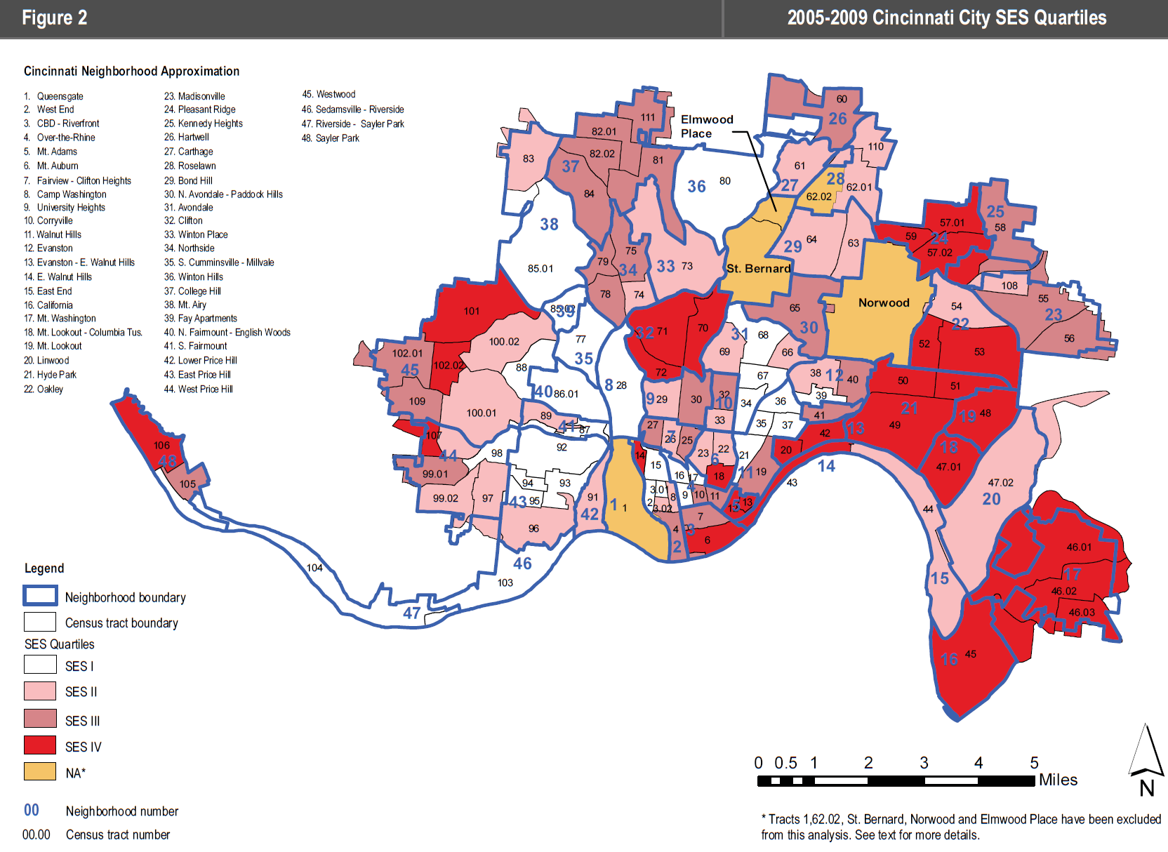
Table 5: Covid-19 Virus Confirmed Cases by Neighborhood
 |  |  | Case Count |  |  |  |  | Case Count
Neighborhood | Jun 1 | Jul 7 |  | Aug 13 | %Inc | Neighborhood | Jun 1 |  | Jul 7 | Aug 13 | %Inc
Queensgate | 2 | 2 |  | 3 | 50.0% | Roselawn | 20 |  | 65 | 114 | 470.0%
West End | 13 | 63 |  | 95 | 630.8% | Bond Hill | 29 |  | 93 | 132 | 355.2%
CBD-Riverfront | 9 | 38 |  | 105 | 1066.7% | N. Avondale – Paddock Hills | 7 |  | 25 | 51 | 628.6%
Over-the-Rhine | 7 | 50 |  | 85 | 1114.3% | Avondale | 47 |  | 122 | 186 | 295.7%
Mt. Adams | 0 | 4 |  | 8 | NA | Clifton | 18 |  | 38 | 70 | 288.9%
Mt. Auburn | 11 | 39 |  | 69 | 527.3% | Spring Grove Village | 5 |  | 17 | 25 | 400.0%
Clifton/University Heights—Fairview (CUF) | 9 | 45 |  | 128 | 1322.2% | Northside | 17 |  | 43 | 70 | 311.8%
Camp Washington | 2 | 6 |  | 20 | 900.0% | S. Cumminsville | 3 |  | 9 | 12 | 300.0%
Corryville | 3 | 13 |  | 31 | 933.3% | Winton Hills | 12 |  | 34 | 52 | 333.3%
Evanston | 19 | 61 |  | 106 | 457.9% | College Hill | 45 |  | 162 | 229 | 408.9%
E. Walnut Hills | 8 | 18 |  | 34 | 325.0% | Mt. Airy | 40 |  | 127 | 190 | 375.0%
Walnut Hills | 20 | 56 |  | 84 | 320.0% | Villages at Roll Hill | 3 |  | 22 | 29 | 866.7%
East End | 0 | 2 |  | 6 | NA | N. Fairmount | 5 |  | 19 | 24 | 380.0%
California | 0 | 1 |  | 1 | NA | S. Fairmount | 3 |  | 32 | 45 | 1400.0%
Mt. Washington | 27 | 55 |  | 86 | 218.5% | Lower Price Hill | 8 |  | 16 | 18 | 125.0%
Columbia-Tusculum | 1 | 2 |  | 6 | 500.0% | East Price Hill | 154 |  | 224 | 272 | 76.6%
Mt. Lookout | 9 | 14 |  | 35 | 288.9% | West Price Hill | 114 |  | 198 | 292 | 73.7%
Linwood | 1 | 2 |  | 3 | 200.0% | Westwood | 209 |  | 451 | 617 | 195.2%
Hyde Park | 20 | 35 |  | 92 | 360.0% | Sedamsville | 2 |  | 3 | 7 | 250.0%
Oakley | 29 | 56 |  | 114 | 293.1% | Sayler Park | 1 |  | 9 | 21 | 2000.0%
Madisonville | 18 | 56 |  | 108 | 500.0% | East Westwood | 21 |  | 40 | 52 | 147.6%
Pleasant Ridge | 60 | 84 |  | 108 | 80.0% | Pendleton | 0 |  | 7 | 17 | NA
Kennedy Heights | 20 | 45 |  | 69 | 245.0% | English Woods | 1 |  | 1 | 2 | 100.0%
Hartwell | 42 | 78 |  | 105 | 150.0% | Riverside | 3 |  | 5 | 14 | 366.7%
Carthage | 11 | 23 |  | 29 | 163.6% | Millvale | 2 |  | 11 | 17 | 750.0%
Source: Cincinnati Health Department June 1, July 7, August 13
Table 5 shows the trends in the entire list of Cincinnati neighborhoods. The author will provide periodic updates.

Michael Maloney is Convener of the Urban Appalachian Community Coalition, a community organizer and social researcher. His publications include the five editions of the Social Areas of Cincinnati: Analysis of Social Needs (vols. 4-5 with Christopher Auffrey).

