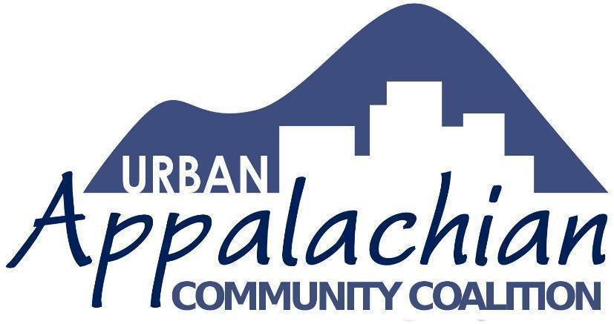

UACC invites applications for

Urban Appalachian Leadership Project Innovation Grants
The Urban Appalachian Community Coalition (UACC) is accepting applications from Greater Cincinnati residents to plan and implement projects that expand applicants’ knowledge of and involvement with well-defined aspects of Appalachian history, culture, and/or current issues affecting rural or urban Appalachians.
Project support is part of the Urban Appalachian Leadership Project (UALP), envisioned as a coalition of students and young adults, community advocates, scholars, artists, and others who empower community members to foster cultural awareness and leadership skills among urban Appalachians. By acknowledging diversity within cultural identity, the UALP seeks to connect with our history and shape our future by engaging in conversations and activities that explore what it means to be Appalachian.
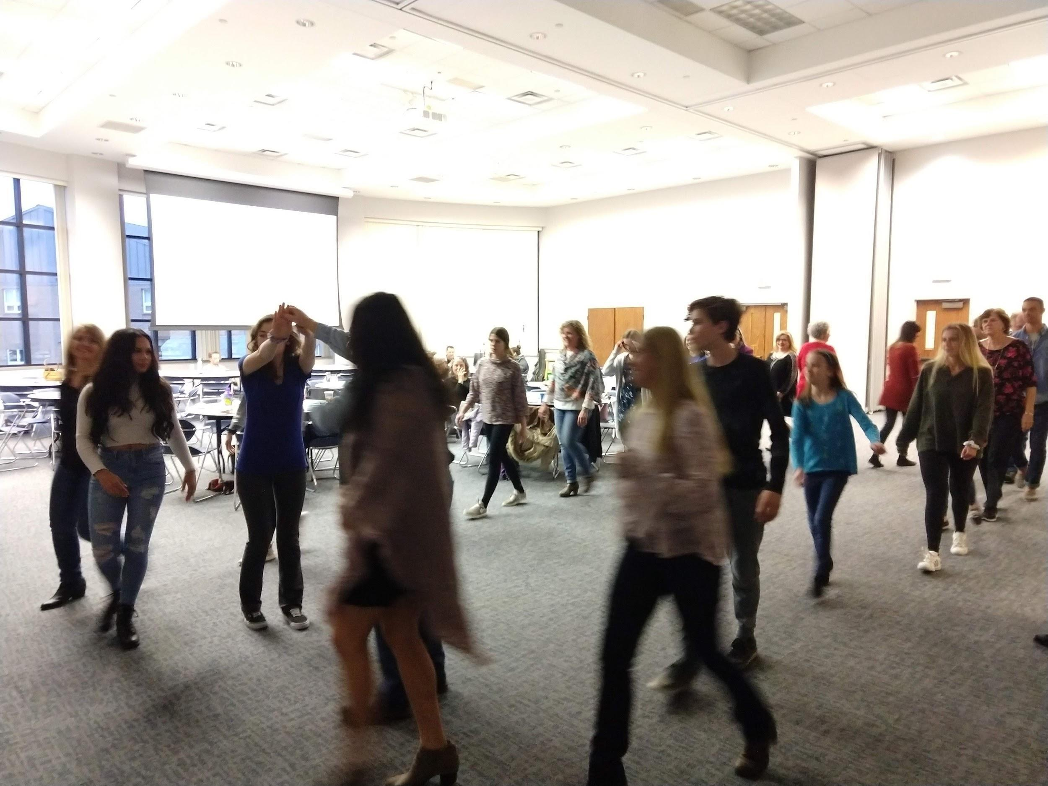
Community Square Dance
Applications will be accepted and reviewed on a continuing, case-by-case basis. While the project should be completed within 12 months, there is not a submission deadline. Applicants of any age may apply for Mini-grants of up to $2000. Adult partners are required for applicants under 18. Awards will go to projects:
- rooted in one or more of the humanities or sciences, for example, arts and culture, community development, history, politics, labor, education, language, ecology, health issues, etc.
- engaging both project participants and the public in topics related to Appalachia or of interest to Appalachians
UACC is committed to encouraging leadership development within our Appalachian community. Projects including young people should assure that youth participants are actively engaged with the development of the proposal, not just the proposed beneficiaries. Each project must promote knowledge-sharing through some form of community engagement or public presentation.
UALP will provide guidance and support for all projects, including hosting regular gatherings for information sharing and community building.
Funds have supported projects such as:
- student-led educational outreach
- researching West Virginia coal mine history
- arts-oriented performances at schools, festivals, and the 2019 Appalachian Studies Conference
General ideas for project-related activities:
- Planning and hosting Appalachian cultural events such as literary and/or musical performances, film series, or theatre and art exhibitions
- Creating/archiving material uniquely reflective of Appalachian issues including oral histories
- Presenting lectures, panel discussions or workshops on issues that connect to Appalachian themes or topics of value
- Action research related to social matters affecting urban and rural Appalachians, including health conditions, economic or other social injustices, school leaving, unemployment, and the opioid crisis
- Development of educational and other resources for use by the Appalachian community
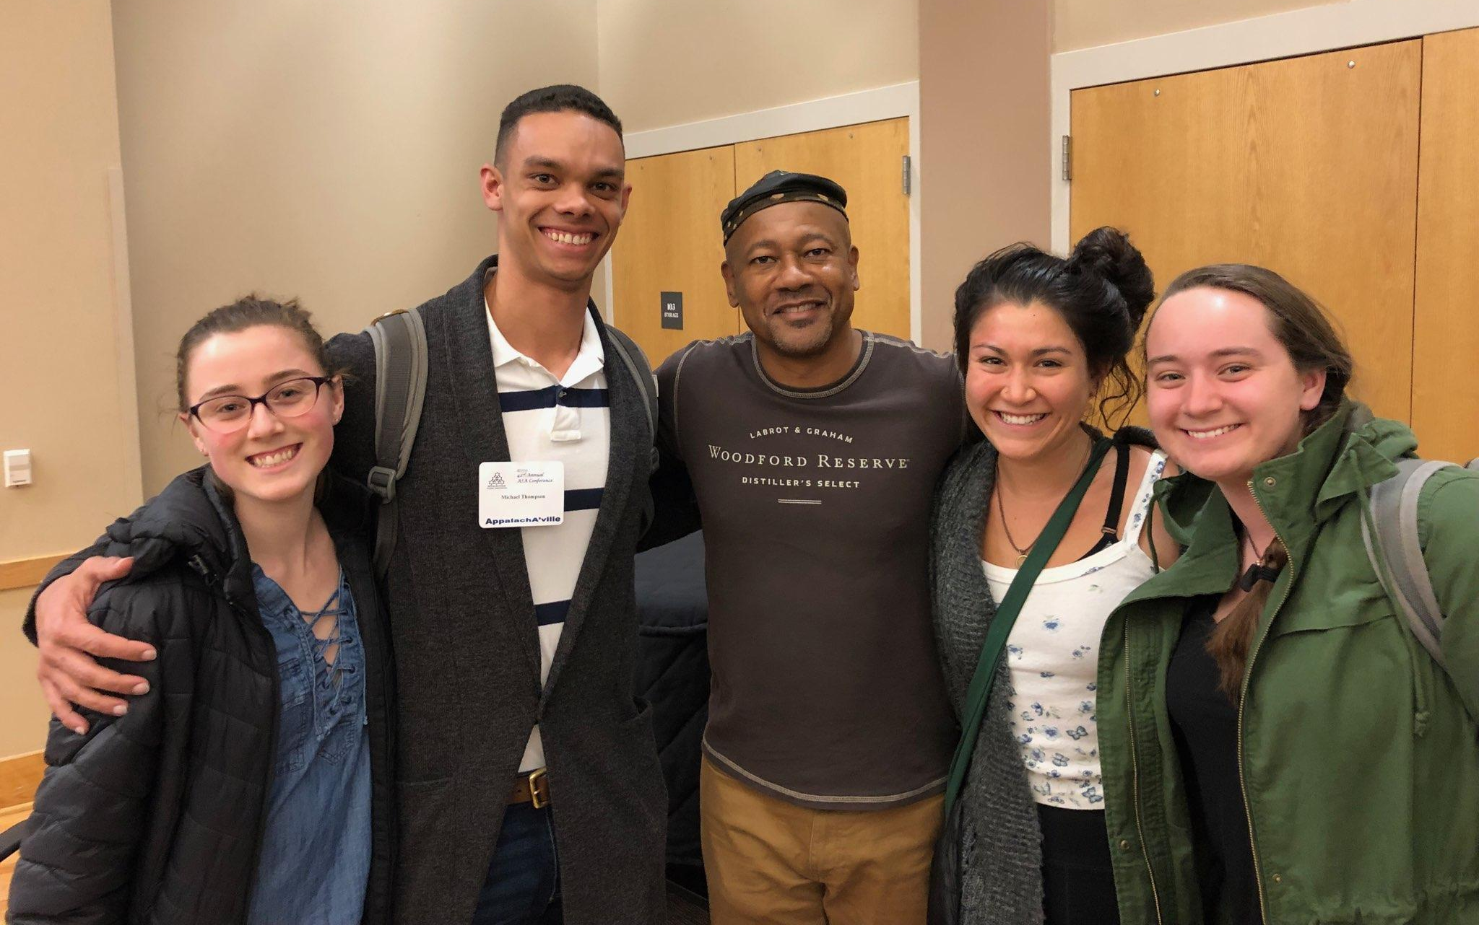
UALP Student Leaders with former KY Poet Laureate Frank X Walker
at a recent Appalachian Studies Association Conference

Appalachian Innovation Grant Application
Applicant
Name
Address
City | State | Zip
Phone | E-mail
School or Community Organization, if applicable
Who Else Will Be Involved in the Project? (Use additional space, if necessary.)
Name
Address
City | State | Zip
Phone | E-mail
Project Description:
(Please provide a narrative summary of the project, including some reasons for why you think the work will have a positive impact on others. Use additional space if needed.)
Describe proposed project activities:
(Include any other details related to project activities that you believe are important to share.)
Desired Outcome:
Ideas about sharing results: (How do you envision sharing what you will have learned with your community and UACC?)
What level of funding are you requesting and how will it be useful to your project? (Grants are generally in the $500 - $2,000 range.)
____________________________________________________________________________________________________________________

Please provide an estimated breakdown related to the above support request and include any relevant narrative explanations.
(UALP funding may be used in various ways—stipends to support time and labor of people involved in the project, travel expenses or admission fees related to attending educational or cultural venues, material cost of supplies and/or food-related events, the purchase of equipment or resources that promote Appalachian-themed education, etc. Use additional space if needed.)
Estimated Project Start Date: | Estimated Project Completion Date:
Further information or application assistance may be obtained by emailing leadership@uacvoice.org.

