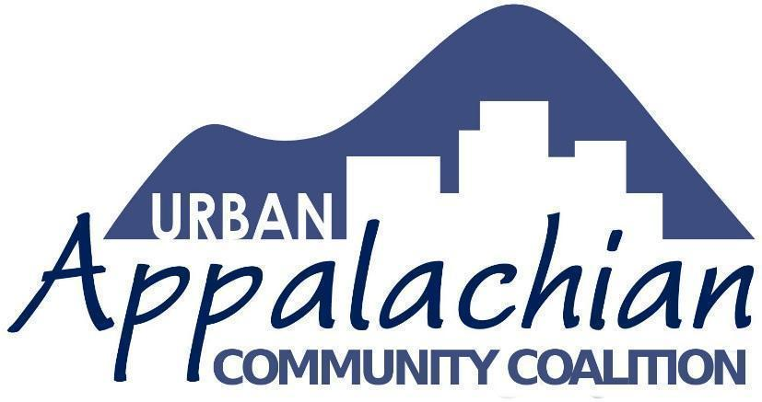

UACC invites applications for Appalachian Innovation Grants
Applications accepted on a rolling basis in 2019: September 15, October 15, and November 15.
The Urban Appalachian Community Coalition (UACC) is accepting applications from greater Cincinnati youth and young adults for the planning and implementation of projects that will expand the applicant’s knowledge of and involvement with a well-defined aspect of Appalachian history, culture, and/or current issues affecting rural or urban Appalachians.
Mini-grants of up to $2,000 are available. Funds have supported projects such as:
- student-led creative writing
- researching West Virginia coal mine history,
- presenting public performances at schools, festivals and the 2019 Appalachian Studies Conference
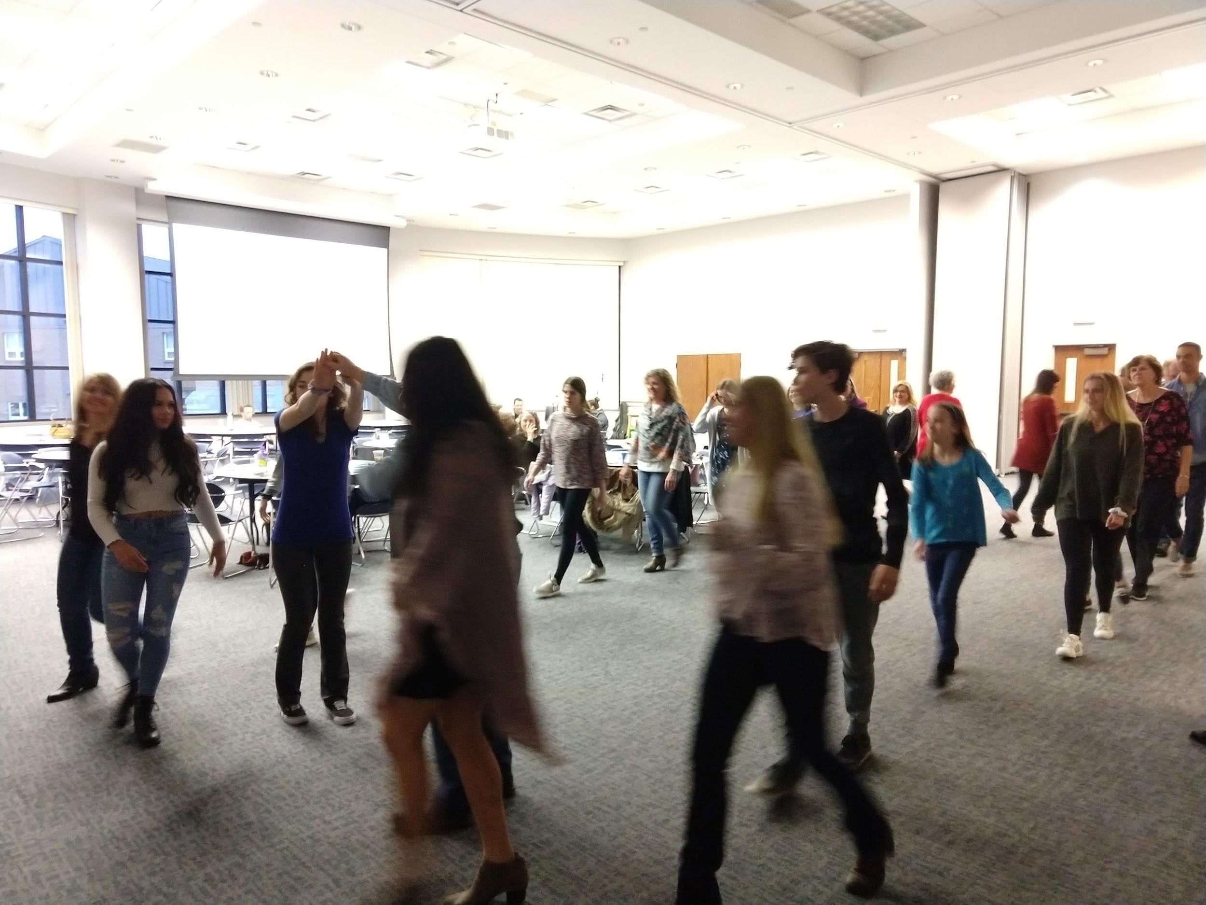
Community Square Dance
Awards will go to projects:
- rooted in one or more of the disciplines of the humanities or sciences,
- enlisting the participation of mentors in the project’s planning and execution,
- engaging the public in topics related to Appalachia or of interest to Appalachians.
Eligible participants will work in partnership with an adult mentor who may be from an educational, institutional, or community-based organization. Mentors may apply jointly with their mentees but the young leader(s) should be actively engaged with the development of the proposal. Each project must reflect an element of community engagement such as a public presentation to share what has been learned. Accepted applicants will meet with other teams and members of UACC at quarterly gatherings for skills development, information sharing, and community building.
Priority will be given to proposals that originate from youth-led initiatives. “Youth” is loosely regarded as ages 14-26. Project staff members will provide guidance in the development of applications if requested.
General ideas for project-related activities:
- Attending, developing and/or implementing Appalachian cultural events such as creative writing open mics, film series, or theatre and art exhibitions;
- Collecting/archiving material uniquely reflective of Appalachian issues including oral histories;
- Producing lectures, panel discussions;
- Engaging in specific research or action related to social matters affecting urban and rural Appalachians, including health conditions, economic or other injustices, school leaving, unemployment, and the opioid crisis;
- Development of cultural resources that complement public programming
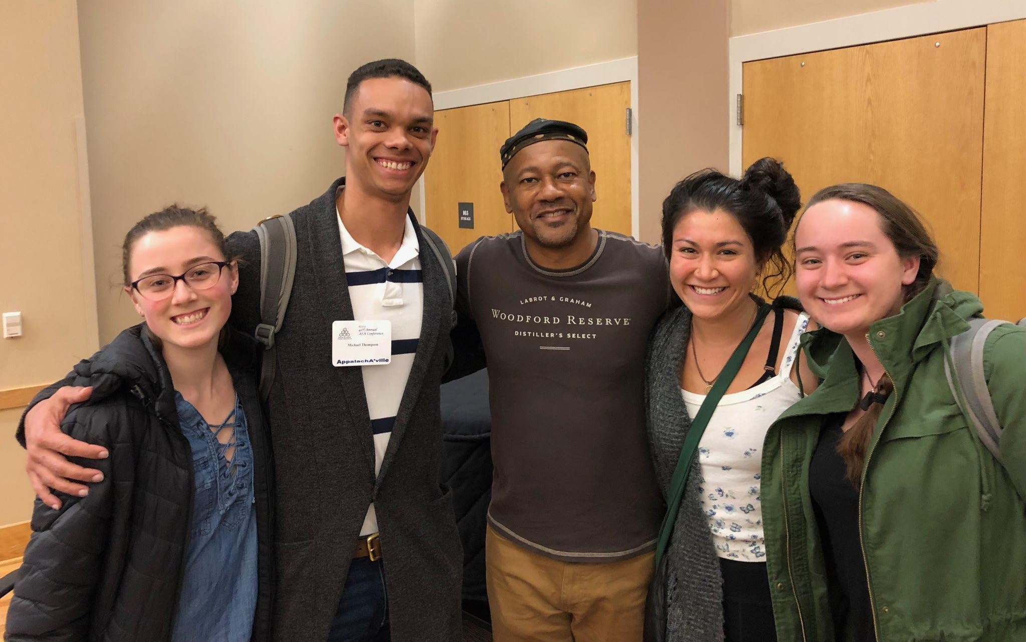
UALP Student Leaders with former KY Poet Laureate Frank X Walker
Cincinnati is home to thousands of Appalachian migrants and their descendants, a diverse group with a shared legacy. UACC recognizes that both the history and current experiences of Urban Appalachians shape our identities, and work to strengthen the irrepressible spirit that lives within these community and individual stories.
The Urban Appalachian Leadership Project (UALP) is envisioned as a coalition of students and young adults, community advocates, scholars, artists, and others who empower community members to foster cultural awareness and leadership skills among urban Appalachian youth and young adults. By acknowledging diversity within cultural identity, the UALP seeks to connect with our history and shape our future by engaging in conversations and activities exploring what it means to be Appalachian.

Appalachian Innovation Grant Application
Applicant
Name
Address
City | State | Zip
Phone | E-mail
School or Community Organization
Who Else Will Be Involved in the Project? (Use additional space, if necessary.)
Name
Address
City | State | Zip
Phone | E-mail
Project Description:
(Please provide a narrative summary of the project, including some reasons for why you think the work will have a positive impact on others. Use additional space if needed.)
Describe proposed project activities:
(Include any other details related to project activities that you believe are important to share.)
Desired Outcome:
Ideas about sharing results: (How do you envision sharing what you will have learned with your community and UACC?)
What level of funding are you requesting and how will it be useful to your project? (Grants are generally in the $500 - $2,000 range.)
____________________________________________________________________________________________________________________

Please provide an estimated breakdown related to the above support request and include any relevant narrative explanations.
(UALP funding may be used in various ways—stipends to support time and labor of people involved in the project, travel expenses or admission fees related to attending educational or cultural venues, material cost of supplies and/or food-related events, the purchase of equipment or resources that promote Appalachian-themed education, etc. Use additional space if needed.)
Estimated Project Start Date: | Estimated Project Completion Date:

Further information or application assistance may be obtained by emailing leadership@uacvoice.org.

