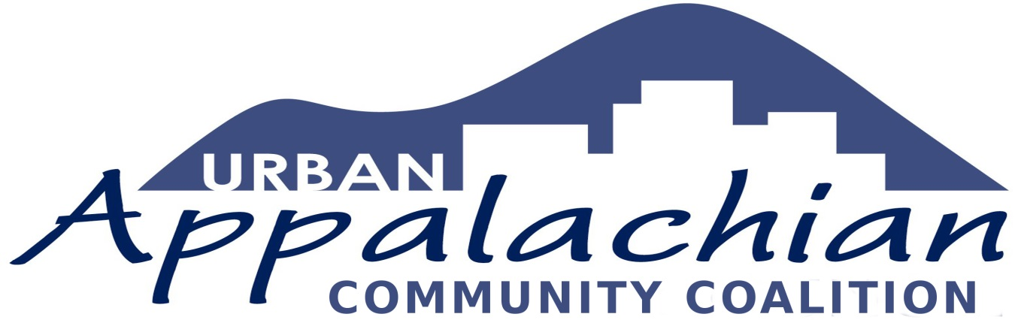
UACC Core Team
John Bealle
Jeffrey Dey
Pauletta Hansel
Nancy Laird
Mike Maloney
Jeffrey Stec
Maureen Sullivan
Debbie Zorn

5829 Wyatt Avenue
Cincinnati, Ohio 45213
513.531.8799
Announcing…
Urban Appalachian Leadership Project Innovation Grants
Request for Proposals
The Urban Appalachian Community Coalition (UACC) seeks proposals to foster cultural awareness and leadership skills among urban Appalachian youth and young adults as a part of the recently formed Urban Appalachian Leadership Project (UALP). Cincinnati is home to thousands of Appalachian migrants and their descendants, a diverse group with a shared legacy. UACC recognizes that both the history and current experiences of Urban Appalachians shape our identities, and work to strengthen the irrepressible spirit that lives within these community and individual stories. The UALP is envisioned as a coalition of students and young adults, community advocates, scholars, artists, and others who empower community members to acknowledge diversity within cultural identity, connect with our history and shape our future by engaging in conversations and activities exploring what it means to be Appalachian.
Eligible participants will work in partnership with an adult mentor who may be from an educational, institutional, or community-based organization. Mentors may apply jointly with their mentees but the young leader(s) should be actively engaged with the development of the proposal. If more space is required or if there is more than one mentee to identify, that information can be listed on another page. Young leaders and mentors will design and actively engage in a project that features Appalachian history, culture, and/or current social issues affecting rural or urban Appalachians. Each project must reflect an element of community engagement such as a public presentation to share what has been learned. We anticipate quarterly gatherings of all participants for skills development activities, information sharing, and community building. Applications will be accepted on a rolling basis with deadlines on the following dates in 2018: September 15, October 15, and November 15; applicants should expect a response by the beginning of the month following their proposal. The time frame for actively developing and implementing the project should take place within one academic year. Grants are generally in the $500 - $2,000 range.
More about Possible Projects
Urban Appalachian Leadership Project Innovation Grants should expand the applicant’s knowledge of and involvement with a well-defined aspect of Appalachian culture, history, or social issues. Some examples of project-related activities may include attending, developing and/or implementing Appalachian cultural events; collecting/archiving material uniquely reflective of Appalachian issues; engaging in specific research or action related to social matters affecting urban and rural Appalachians, including health conditions, economic or other injustices, school leaving, unemployment, and the opioid crisis. Project staff members will be able to provide guidance in the development of applications if needed.
Further information or application assistance may be obtained by emailing leadership@uacvoice.org.

Urban Appalachian Leadership Project Grants
Application Form
Applicant
Name
Address
City | State | Zip
Phone | E-mail
School or Community Organization
Who Else Will Be Involved in the Project? (Use additional space, if necessary.)
Name
Address
City | State | Zip
Phone | E-mail
Project Description:
(Please provide a narrative summary of the project, including some reasons for why you think the work will have a positive impact on others. Use additional space if needed.)
Describe proposed project activities:
(Include any other details related to project activities that you believe are important to share.)
Desired Outcome:
Ideas about sharing results: (How do you envision sharing what you will have learned with your community and UACC?)

What level of funding are you requesting and how will it be useful to your project? (Grants are generally in the $500 - $2,000 range.)
Estimated Project Start Date: | Estimated Project Completion Date:
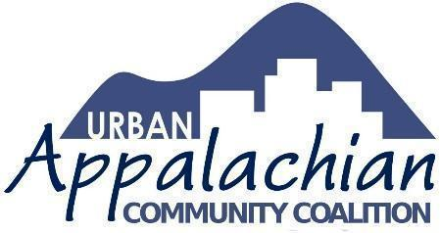
For more information about the Urban Appalachian Community Coalition, visit our website at www.uacvoice.org.

